STATEMENT OF ORIGINALITY

To:
Editor-in-chief
ETERNAL (English, Teaching, Learning, and Research Journal) JOURNAL

With this letter we declare that:
Title of article: Students and Teachers’ Anxiety Level in Learning English during the Emergency Remote Teaching in Indonesia
Author : 1. Ni Putu Intan Bidari
2. Made Hery Santosa
3. Gede Mahendrayana
has been approved by the co-author/s to be published in ETERNAL (English, Teaching, Learning, and Research Journal) JOURNAL, does not contain plagiarism as a whole or in parts, and is not currently being submitted/ processed in other journals.

Singaraja, September, 19th, 2021
Authors Signatures
1st Author (Ni Putu Intan Bidari) 
2nd Author (Made Hery Santosa, S.Pd., M.Pd., Ph.D.) 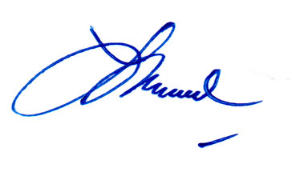
3rd Author (Gede Mahendrayana S.Pd., M.Pd.) 