**ANALYSIS OF HISTORICAL BUILDINGS NGAWEN TEMPLE IN MAGELANG**

**Rizki Sariningtias1), Reza Indriani2), Anisa Solihati3), Alya kamila4), Megita Dwi Pamungkas5)**

1,2,3,4,5Tidar University

1,2,3,4,5Kapten Suparman Street No. 39 Magelang, Central Java, Indonesia

E-mail: [riskisariningtias@gmail.com](mailto:riskisariningtias@gmail.com) 1), [reza26indri@gmail.com](mailto:reza26indri@gmail.com)2), [solihatianisa@gmail.com](mailto:solihatianisa@gmail.com) 3), [alyakamila512@gmail.com](mailto:alyakamila512@gmail.com) 4), [megitadwip@untidar.ac.id](mailto:megitadwip@untidar.ac.id) 5)

***Abstract:***

*The analysis of historical buildings Ngawen Temple has a purpose to know the history of Ngawen Temple and know the approach to the geometry of the Ngawen temple. This type of research is descriptive research with a qualitative approach. The subject of this research is the historical building of Ngawen Temple. The data collection techniques used in this research are interviews and documentation (observation) directly. The interview was done with the temple officers who were around the building and the documentation was taken directly. The data analysis technique is done by analyzing the buildings related to the geometry such as the shape of the building on the Ngawen temple. The results of this study were obtained, namely, Ngawen Temple set in Buddhism. The Ngawen temple complex consists of 5 (five) temples that line the parallel from north to south. Temple building facing the east. From the south of Candi Ngawen I, II, III, IV, and V with each temple to plan the square. One of the uniqueness of Ngawen temple is the existence of 4 lion statues in every corner of the temple II and Candi IV. Another uniqueness is the architecture of the temple, found in the statue of a lion that supports the four sides of the temple building that was reconstructed from the five buildings. The carved style of the lion statue resembles the lion symbol of the country of Singapore, and serves the rainwater that comes out through the mouth of the statue. The shape of the Ngawen temple resembles the geometry of the cuboid, the rectangular pyramidal frustum, and the rectangular pyramid.*

***Keywords:****History of Ngawen temple, building analysis, geometry approach.*

B

**INTRODUCTION**

uilding is a work of art in the field of architecture. Architectural work is a tangible result of the imagination and copyright of experts to make life more enjoyable and more perfect than before. Architecture has a strong bond with geometry because of its need for regularity and efficiency of construction, and a desire to create aesthetically satisfying structures. Geometric shapes will be processed into beautiful works, doors and windows show the character of geometric shapes.

Geometry is the science of mathematics that learns about the field and space (Hafizin, 2018). Geometry also presents an understanding of the point, line, and its properties and measurements. According to Widyastuti et al (Hafizin, 2018). Geometry also presents an understanding of the point, line, and its properties and measurements. According to Widyastuti et al (Hafizin, 2018) Geometry objects are abstract, so it can potentially elicit various difficulties in learning. Ismadji (swinging, 2019) states the objects spoken of in the geometry of the space are abstract objects. Geometry studies are abstract and are related to the wake-up of two or three dimensional, including cube, cuboid, prism, pyramid, and others.

Mathematics and culture are considered to be two things that have no relationship. Not many people consider these two things as impossible to put together. But without realizing Etnomatematika put together these two things, Etnomatematika is as an approach that relates between mathematics and culture, this association is expected to be able to increase the love of students to the culture so that students can know the benefits of mathematics in a cultural perspective (Kencanawati, 2017 in Oktaviani, 2019).

Geometry can teach a way to give appreciation to the world. This is because geometry can be found not only on the structure of the solar system, but also natural phenomena such as on the formation of geology, rocks and crystals, plants and flowers even in animals. Geometry also includes a large portion of our synthetic nature or universe such as art, architecture, automobiles, machinery, and virtually everything a human-created has elements of geometric shapes. For example, the use of geometry in architecture can be seen in historical buildings, one of which is the Ngawen temple. Based on the background, the problem is taken as a matter of how the history of Ngawen temple and the geometry approach to the building of Ngawen Temple. The purpose of this writing is to know the history of Ngawen Temple and know the geometry approach of Ngawen temple.

**METHOD**

This research is a descriptive study with a qualitative approach aimed at knowing the history of Ngawen temple and knowing the geometry approach of Ngawen temple. Research on the history and approach of building on this geometry is implemented in Ngawen Temple building, Ngawen village, Muntilan District, Magelang regency at the coordinates $07°{36}^{'}14,7\text{ LS dan 110°16'21}\text{,4} BT$. The object of this study is the historical building of Ngawen Temple. Data collection techniques used in research are with interviews and documentation (observation) directly. The interview was done with the temple guards who were in the building and the documentation was taken directly. The data analysis technique is done by analyzing the buildings associated with the Geometric such as the shape of the building on Ngawen temple.

**FINDINGS AND DISCUSSION**

1. **Ngawen Temple History**

In the era of Hindu-Buddhist kingdoms many kingdoms in Indonesia. These kingdoms provide various relics such as inscriptions, temples, books, and others. Most of these kingdoms are located in Java Island. Therefore, many royal relics on the island of Java. Among the relics are many famous relics such as Borobudur Temple, Prambanan Temple, Gedongsongo temple, etc. There are also many small temple relics or nonintact temples that are less well known by the wider public, such as Asu Temple, Wukir temple, Lumbung Semi temple, and Ngawen temple.

Ngawen temple located in Ngawen village, Muntilan District, Magelang Regency, Central Java is set in Buddhism. This is evidenced by the findings of the Dhyani Budha Ratnasambhawa statue in Candi II and the statue of Dhyani Budha Amithaba in Candi IV. Despite the Buddhist background, the shape of the Ngawen temple is almost similar to the Hindu Temple building. This is due to the building of a tapered temple. The building is also a large temple and small temple which is characterized by a Hindu-patterned temple. But when observed, this temple has a stupa and a terrace (Undak-Undak) that becomes a symbol in Buddhist temples. This temple was used as a place of worship.

Ngawen temple has not been known for sure when and who built it. This is because the inscription that mentions it is inevitably not found. Until today, research is still conducted by ancient experts and historians. It is estimated that the construction of this temple is a period with the construction of Borobudur temple and Gunung Wukir Temple, in the range of the 8th and 9th centuries, during the ancient Mataram kingdom.

Based on the information of the temple officer, an ancient scholar De Casparis argued that the archaeological complex was constructed by mutual assistance between the king of Pikatan Dyah Siladu of the Sanjaya dynasty and King Samaratungga of Syailendra dynasty. The historical analysis is based on the central coral inscription in 824 M. In this inscription is mentioned, King Samaratungga erected a holy building in a place which means bamboo forest. Ngawen village was thought to be one of the villages overgrown by bamboo forest, and in the north of Ngawen village there is now a village called Gunungpring, where there is a hill that is still overgrown by bamboo groves.

The discovery of Ngawen temple began in the Dutch colonial period, namely in 1874. After the discovery, then continued with various studies, and the restoration was only performed in 1925-1927. At the restoration and reconstruction was not able to produce the whole temple. This is because many lost stones are made possible by natural disasters such as earthquakes or volcanic eruptions, which has swept away the rocks. From that restoration only produced the legs of the temple and the body of the temple II. It is estimated at the II temple is still less roof as high as 2-3 meters. To date, there are still efforts to reconstruct the temple by the institution that has its own, namely the Central Java Cultural Reserve Preservation Hall. Last time, Reconstruction was held in 2011-2012 at Temple IV.

1. **Geometric Approach Ngawen Temple**

The Ngawen temple complex consists of 5 (five) temples that are lined parallel from north to south. Temple building facing the east. From the south of Ngawen Temple I, II, III, IV, and V with each temple to plan the square. The II and IV temples have the same size and shape of construction. One of the uniqueness of Ngawen temple is the existence of 4 lion statues in every corner of the temple II and Temple IV. Another uniqueness is the architecture of the temple, found in the statue of a lion that supports the four sides of the temple building that was reconstructed from the five buildings. The carved style of the lion statue resembles the lion symbol of the country of Singapore, and serves the rainwater that comes out through the mouth of the statue.

Ngawen temple complex is approximately 900 square meters. Based on the results of reconstruction that produces only the body of Temple II, temples other than Temple II are only the foot of the temple in the form of cuboid and variant size.

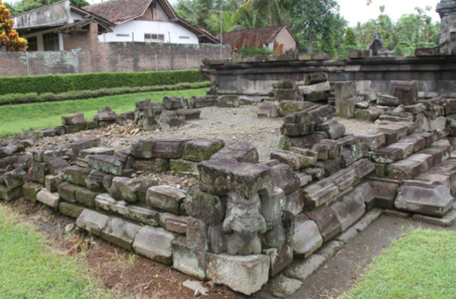

Picture 1. Temple foot

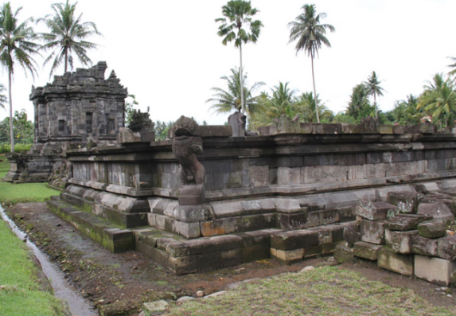

Picture 2. Temple Foot IV

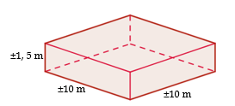

Picture 3. Temple foot Look Side



Picture 4. Temple Foot Front View

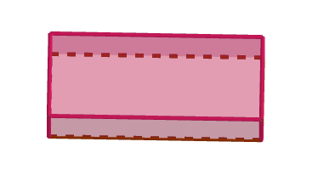

Picture 5. Temple Foot Look Up

Likewise, in Temple II, because this temple is not found in the form of the stupa, this temple is also the only variant of the beam that is arranged. The Footplan of Ngawen II temple measuring 13,36 m x 12,82 m. This site is the same as the IV temple. The height of the temple is 2,32 m, and the East Side viewer is 2,42 m. Over the foot of the temple is the lobby that surrounds the temple body of 1,10 m. While the separate temple gate is the size, width 4,9 m, gate part 1,05 m and height 2,1 m. Meanwhile, on the roof is the rectangular pyramidal frustum, and the upper part of the arch in the form of a rectangular pyramid.

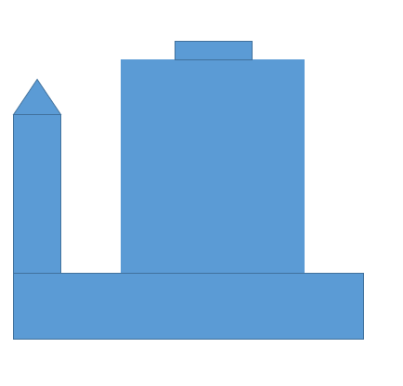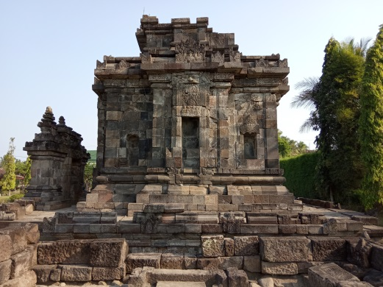

Picture 7. Sketch Temple II Look Side

Picture 6. Candi II Side View

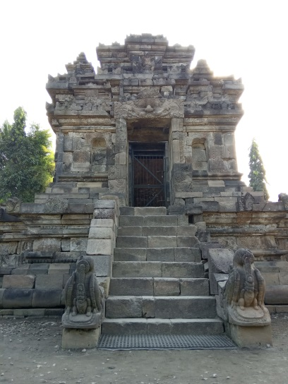

Picture 9. Temple Sketch II Front View

Picture 8. Temple II Front View

**CONCLUSIONS**

Ngawen temple located in Ngawen village, Muntilan District, Magelang Regency, Central Java is set in Buddhism. This is evidenced by the findings of the statue Dhyani Buddha Ratnasambhawa in the temple II and the statue of Dhyani Budha Amithaba in Candi IV. Despite the Buddhist background, the shape of the Ngawen temple is almost similar to the Hindu Temple building. It is estimated that the construction of this temple is a period with the construction of Borobudur temple and Gunung Wukir Temple, in the range of the 8th and 9th centuries, during the ancient Mataram kingdom. The discovery of Ngawen temple began in the Dutch colonial period, namely in 1874. After the discovery, then continued with various studies, and the restoration was only performed in 1925-1927.

Ngawen temple complex is approximately 900 square meters. Based on the results of reconstruction that produces only the body of Temple II, temples other than Temple II are only the foot of the temple in the form of a beam and variant size. Likewise, in Temple II, because this temple is not found in the form of the stupa, this temple is also the only variant of the beam that is arranged. The Footplan of Ngawen II temple measuring13,36 m x 12,82 m. The foot of the temple is 2,32 m, and the East Side viewer 2,42 m. Above the foot of the temple is the lobby that surrounds the temple body as wide as 1,10 m. While the separate temple gate is the size, width 4,9 m, the gate section 1,05 m and height 2,1 m. Meanwhile, on the roof is the rectangular pyramidal frustum, and the upper part of the arch in the form of a rectangular pyramid.

**GREETING THANK YOU**

With the completion of this research article, the author thanked Allah SWT. Over the overflow of the gift and it's her nose so that the authors can implement and complete the research articles, both parents who have helped and supported in working on the research articles, guards Ngawen Temple who have assisted the research process and mathematics education lecturer who guided us in the preparation of research articles.

**REFERENCES**

Perpustakaan Nasional Republik Indonesia. (2014). “Candi Ngawen”. [*https://candi.perpusnas.go.id/templates/deskripsi-jawa_tengah-candi_ngawen_53*](https://candi.perpusnas.go.id/templates/deskripsi-jawa_tengah-candi_ngawen_53) *.* Diunduh pada tanggal 24 April 2020, pukul 20.00

Sukandar, Amat. (2017). “Candi Ngawen di Muntilan”. [*https://siagaindonesia.com/161964/candi-ngawen-di-muntilan.html/amp*](https://siagaindonesia.com/161964/candi-ngawen-di-muntilan.html/amp) *.* Diunduh pada tanggal 24 April 2020, pukul 20.30

E Widyaningsih. (2020). Analisis Bangunan Bersejarah Panggung Krapyak Terhadap Geometri. *Jurnal Ilmiah Pendidikan Matematika*, 8(1), 111-119.

Oktaviani. (2019). Lawang Sewu Dalam Sudut Pandang Geometri. *Jurnal Pendidikan Matematika*, 2(1), 113 – 131.

Alfonsa. 2016. Integrasi Etnomatematika Dalam Kurikulum Matematika Sekolah. *Jurnal Pendidikan Matematika Indonesia*, 1(1), 1 – 6.