MaPan : Jurnal Matematika dan Pembelajaran
p-ISSN: 2354-6883 ; e-ISSN: 2581-172X
Volume 8, No 2, Dec 2020 (1-6)
DOI: https://doi.org/10.24252/mapan.2020v8n2a1

GEOMETRIC TRANSFORMATION ON CARVINGS OF TORAJA TONGKONAN HOUSES
Suri Toding Lembang1), Yusem Ba’ru2)
1Department of Mathematics Education, Universitas Kristen Indonesia Toraja
2Department of Mathematics Education, Universitas Kristen Indonesia Toraja
1Jl. Nusantara No 9 Toraja Utara
2Jl. Nusantara No 9 Toraja Utara
Email: surikaritutu@gmail.com¹),
yusembaru@ukitoraja.ac.id²)

Abstract:

This research aims to examine the mathematical concepts contained in the carving of traditional tongkonan houses and provide information about the meaning contained of each carving in the tongkonan house. The research method used is qualitative research method. The results of the study are obtained by observation and interview. The results obtained that it turns out, in some Toraja carvings, contain the concept of transformational geometry, namely reflection. And the information obtained also that the carvings in the tongkonan house are very loaded with meaning, especially about advice, prayer or hope to all members of the tongkonan..
Keywords: Geometry, Tongkonan Carving, Mathematical Concepts

GEOMETRI TRANFORMASI PADA UKIRAN-UKIRAN RUMAH TONGKONAN TORAJA
Abstrak:

Penelitian ini bertujuan untuk mengkaji konsep matematika yang terdapat pada ukiran rumah adat tongkonan dan memberikan informasi tentang makna yang terkandung dari setiap ukiran yang ada pada rumah tongkonan. Metode penelitian yang digunakan adalah metode penelitian kualitatif. Hasil penelitian yang diperoleh dengan cara observasi dan wawancara. Hasil yang didapatkan bahwa ternyata, dalam beberapa ukiran Toraja, mengandung konsep geometri transformasi, seperti refleksi . Serta informasi yang didapatkan pula bahwa ukiran-ukiran yang ada pada rumah tongkonan itu sangat sarat dengan makna terutama tentang nasehat, doa atau harapan kepada seluruh anggota dari tongkonan tersebut.
Kata Kunci: Geometri Transformasi, Ukiran Tongkonan, Konsep Matematika.

[1]
Copyright © 2021, MaPan : Jurnal Matematika dan Pembelajaran
How to Cite: Suri T L & Yusem B. (2021). Geometri Tranformasi Pada Ukiran-Ukiran Rumah Tongkonan Toraja. MaPan : Jurnal Matematika dan Pembelajaran, x(x), xx-xx.

INTRODUCTION
M

athematics is one of the subjects that are still very difficult to understand and feared by students today. This fear of mathematics is none other than because the defense of mathematics is not familiar with students and the abstract nature of mathematics itself.
Based on the results of interviews with some of their students revealed that it is difficult for them to learn mathematics because there are too many formulas and not context for them. While based on the results of interviews with math student eye teachers, the cause of students difficulty understanding and understanding mathematics is due to a lack of understanding of the basic concepts of mathematics. Based on the results of research one of the mistakes students in solving mathematical problems is due to concept errors (Suri &Yusem: 2018). The teacher revealed that specifically on transformational geomtery material, students are very difficult to talk about translation, dilation, rotation, and reflection. In addition, teachers admit that it is very difficult to explain about the concepts of translation, dilation, rotation, and reflection itself. For this reason, a solution is needed for students and teachers so that students can explore mathematical concepts, especially in transformational geomtery materials. One solution is culture-based mathematical learning. The practice of mathematics in cultural groups is Ethnonomathematika. (D’Ambrosio, U. (1989). Ethnonomathematika is the study of the relationship between mathematics and culture. It refers to a broad set of ideas ranging from different numerical and mathematical systems to multicultural mathematics education. The purpose of ethnonomathematika is to contribute both to cultural understanding and mathematical understanding, but primarily to appreciating the relationship between the two. Toraja is an area rich in culture such as the traditional Toraja house that is Tongkonan. The most dominating cultural elements of this house are unique and interesting carvings. Each motif in the carving of the traditional Tongkonan house has its own meaning. From the traditional house tongkonan actually contains mathematical concepts. If we look closely at the carvings on the traditional tongkonan house, all of them have mathematical concepts, one of which is geomtery transformation. From the traditional house tongkonan actually contains mathematical concepts. Carvings in the Tongkonan House have a type of geometric transformation. In this carving we find many types of geometric transformations, namely translation, dilation, rotation, and reflection.
The results also showed that students were more enthusiastic when taught using Toraja carvings (Suri et al: 2019). This research is expected to examine the mathematical concepts contained in the carving of traditional tongkonan houses and can be obtained teaching materials that can accommodate home-based learning of

tongkonan custom and to find out how the application of teaching materials in mathematical learning.

METHODS
The research method used is qualitative research method. The first to the third stage is done in a quality manner. The first stage is to identify and interview the initial subject of the researcher, namely people who understand and understand about the intricacies of carvings on toraja tongkonan houses in this case are indigenous figures. The second stage is to collect confident data through surveys and further interviews to related sources regarding the meaning of the carvings of toraja traditional tongkonan houses. The third stage is to manage and analyze data sets and conduct publications obtained from survey results and interviews in connection with the meaning and meaning contained in the traditional tongkonan toraja house.
- Identify and Interview
Identify and interview problems by trying to find information on the types of geometric transformations contained in the traditional tongkonan toraja house.
- Collect data
Collecting interview survey data is done by looking for and digging for information about the types of geometric translation contained in the carvings of traditional tongkonan toraja ruman. The interview was conducted to find out the meaning contained in the carvings of traditional tongkonan toraja houses. Interviews are conducted to indigenous figures and related sources.
- Managing and Analyzing data
Conducting data analysis from interview results and data collection on types of geomteri transformation, meaning contained in toraja traditional houses and making teaching materials about traditional tongkonan houses about transformational geometry

RESULTS AND DISCUSSION
Concept of Reflection/Mirroring on Toraja Carvings
        - Type of Carving paqbarre allo
The word paqbarre allo consists of 2 words, namely, barre and allo, barre means roundabout or roundabout and allo means sun. So paqbarre allo is a carving that resembles a circle of the sun with its radiance. This type of carving is found in barrels and barns. The meaning of the carving paqbarre allo is a symbol of greatness and pride for the Toraja people. If noticed, the carving of paqbarre allo is included in the reflection / mirroring of the line x, line y and against point 0 (0,0). However, researchers focused paqbarre allo on the x line as in the image below.
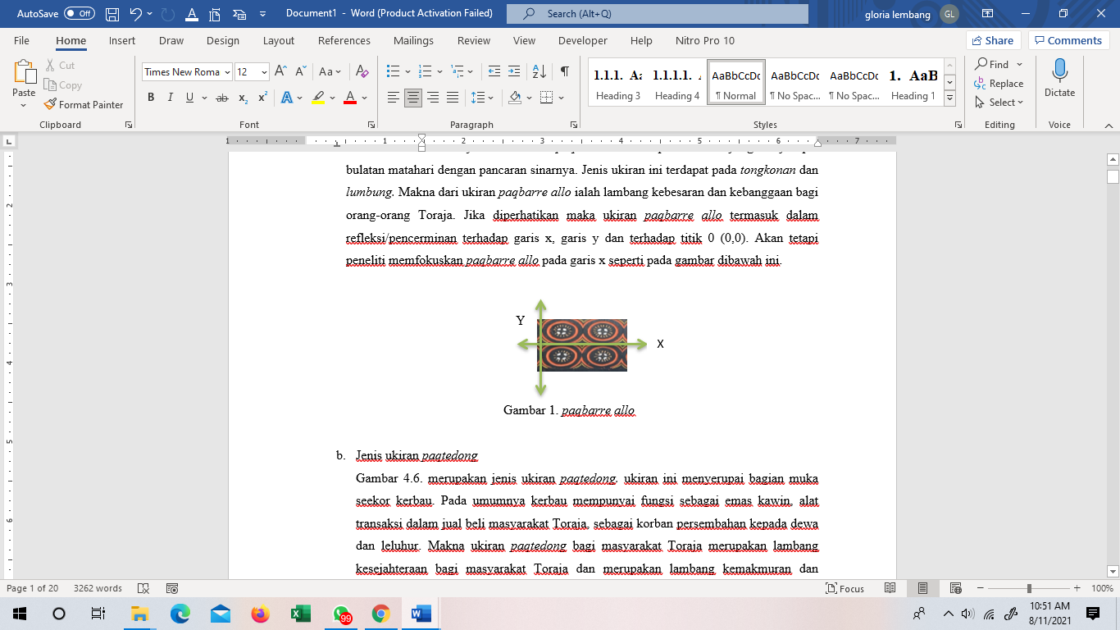
Figure 1. paqbarre allo

- Type Of Carving paqtedong
Figure 2 is a type of paqtedong carving. This carving resembles the face of a buffalo. In general, buffalo has a function as mating gold, a transaction tool in the buying and selling of Toraja people, as a sacrifice of offerings to gods and ancestors. The meaning of paqtedong carving for the Toraja community is a symbol of welfare for the Toraja people and is a symbol of prosperity and life. When carefully observed, the carving of paqtedong is included in the reflection / reflection of the y line.
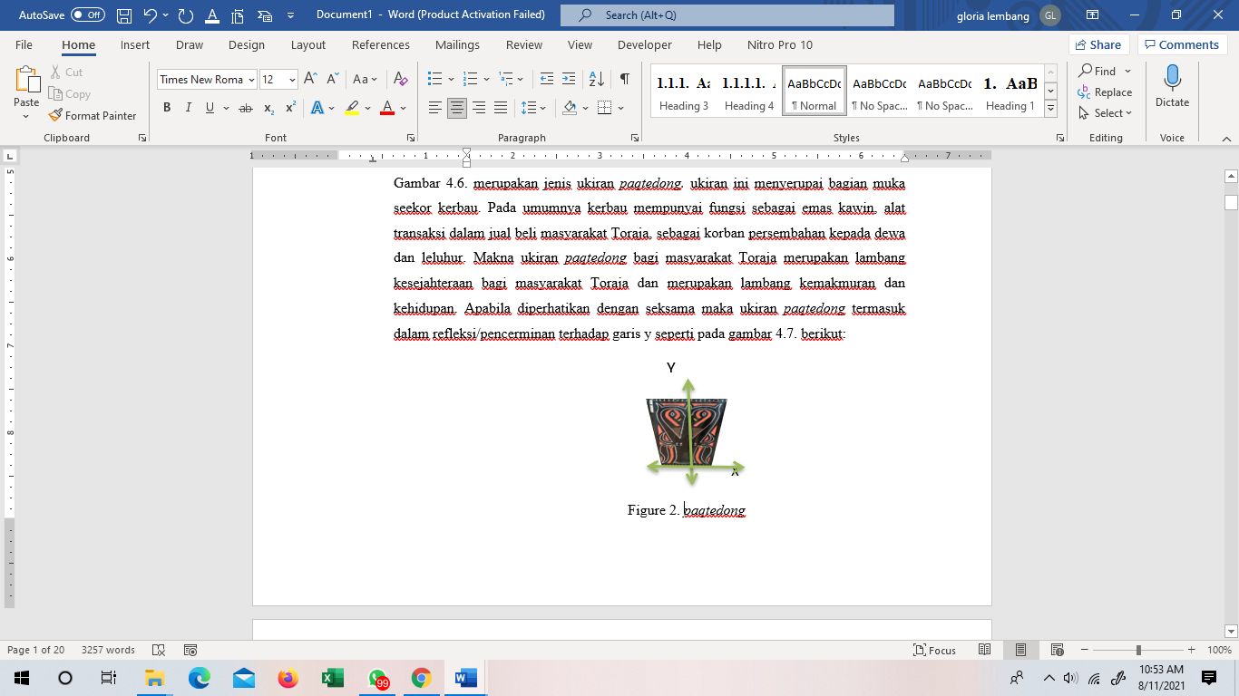
- Type Of Carving paqtakku pare
Figure 3 is a type of carving paqtakku pare. The word paqtakku pare consists of 2 words namely, takku and pare, the word takku means submission and pare means rice. Rice plants are the main plant in Toraja and are considered noble because according to the parents of rice ancestors in the beginning were humans. This carving resembles a submissive rice fruit. The meaning of carving paqtakku pare for the people of Toraja is that in this life it still humbles itself in association like rice that increasingly contains more submission. If carefully observed then the carving of paqtakku pare is included in the mirroring / reflection of the line y = x.

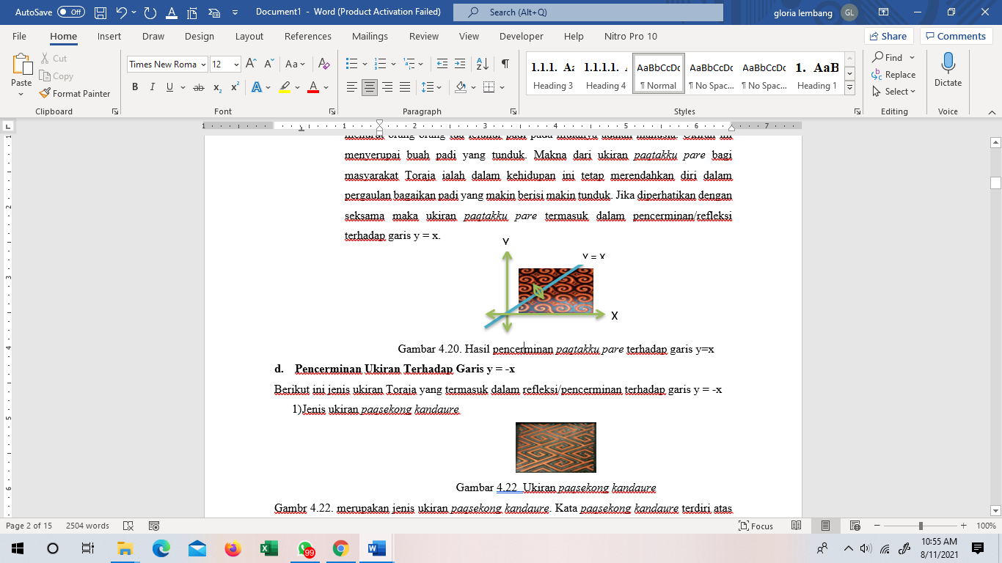
Figure 3. paqtakku pare
- Type Of Carving paqsekong kandaure
Figure 4 is a type of carving paqsekong kandaure. The word paqsekong kandaure consists of two words, namely sekong and kandaure. Sekong means twist or twist and kandaure means the shape of the elbow line. The meaning of the carving of paqsekong kandaure is a derivative or posterity may always live in happiness like light. If carefully observed, the carving of paqsekong kandaure is included in the reflection of the line y = -x
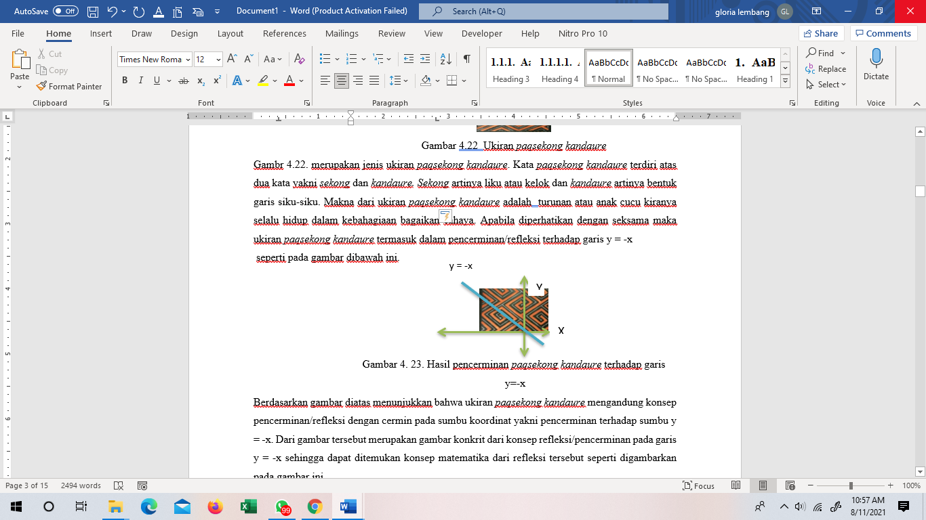
Figure 4. paqsekong kandaure

CONCLUSION
Based on some of the mirroring images above shows that the carving of paqtangkiq pattung II, paqbaranaq II and paqkapuq baka contains the concept of mirroring / reflection with a mirror on the coordinate axis that is mirroring against point 0 (0.0). From the picture is a concrete image of the concept of reflection / mirroring at point 0 (0,0).

REFERENCES

Achmat, Z, 2018. “The Ethnograpich Interview”. FISIP Universitas Airlangga.

D’Ambrosio, U. (1989). On ethnomathematics. Philosophica Mathematica, 2(41), 3-14.

Alfiah dan Supryani, E, 2016. “Perubahan Bentuk Rumah Adat Tongkonan Tana Toraja Berdasarkan Pendapat Teori Lesesau”. Jurnal Teknosains. UIN Alauddin Makassar.
Kurmiasih, M dan Handayani, I, 2017. “Geometri Tansformasi”. FMIPA Universitas Muhammadiyah. Jakarta
Sugiyono. 2018. Metode Penelitian Kuantitatif Kualitatif dan R&D. ALFABETA. Yogyakarta
Suri & Yusem.2018. Analisis Kesalahan Mahasiswa Dalam Menyelesaikan Soal Aljabar Linier Pada Materi Sistem Persamaan Linier. Jurnal FKIP UKI Toraja. Vol. VI No. 3.
Suri dkk. 2019. Ukiran Toraja Sebagai Alat Peraga Untuk Memperkenalkan Bangun Datar. Jurnal FKIP UKI Toraja. Vol VII No 1.
Tandililing, P. 2015. Eksplorasi Geometri Budaya Toraja. Jurnal ilmiah Matematika dan pembelajarannya. (1): 47-57.

