1. Dokumentasi hasil rancang bangun alat praktikum

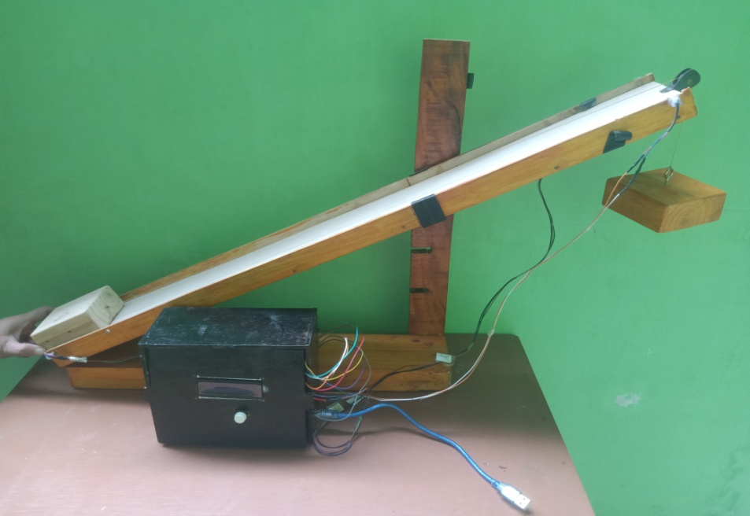

1. Data hasil penelitian

Tabel 1. Data hasil kalibrasi sensor photogate

|  |  |  |  |  |
| --- | --- | --- | --- | --- |
| No. | Sudut | Waktu (t) | | *Error* (%) |
| Stopwatch (X) | Sensor Photogate (Y) |
| 1. | 10 | 0,41 | 0,416 | 1,46 |
| 0,43 | 0,432 | 0,46 |
| 0,43 | 0,433 | 0,69 |
| 0,42 | 0,418 | 0,47 |
| 0,42 | 0,418 | 0,47 |
| 0,44 | 0,446 | 1,36 |
| 0,41 | 0,416 | 1,46 |
| 0,42 | 0,418 | 0,47 |
| 0,43 | 0,432 | 0,46 |
| 0,42 | 0,418 | 0,47 |
| 2. | 20 | 0,47 | 0,476 | 1,27 |
| 0,48 | 0,477 | 0,62 |
| 0,46 | 0,462 | 0,43 |
| 0,50 | 0,490 | 2,00 |
| 0,46 | 0,462 | 0,43 |
| 0,46 | 0,462 | 0,43 |
| 0,50 | 0,492 | 1,60 |
| 0,48 | 0,477 | 0,62 |
| 0,46 | 0,462 | 0,43 |
| 0,46 | 0,462 | 0,43 |
| 3. | 30 | 0,56 | 0,565 | 0,89 |
| 0,50 | 0,506 | 1,20 |
| 0,54 | 0,536 | 0,74 |
| 0,53 | 0,535 | 0,94 |
| 0,54 | 0,550 | 1,80 |
| 0,52 | 0,521 | 0,19 |
| 0,52 | 0,521 | 0,19 |
| 0,54 | 0,535 | 0,74 |
| 0,52 | 0,522 | 0,38 |
| 0,52 | 0,521 | 0,19 |

Tabel 2. Data rata-rata hasil kalibrasi sensor photogate

|  |  |  |  |  |
| --- | --- | --- | --- | --- |
| No. | Sudut | X (sekon) | Y (sekon) | *Error* (%) |
| 1. | 10 | 0,42 | 0,425 | 1,19 |
| 2. | 20 | 0,47 | 0,472 | 0,43 |
| 3. | 30 | 0,53 | 0,531 | 0,19 |

Tabel 3. Data hasil uji coba terbatas

|  |  |  |  |  |
| --- | --- | --- | --- | --- |
| No. | Sudut | Waktu (t) | | Percepatan (m/s2) |
| Stopwatch (X) | Sensor Photogate (Y) |
| 1. | 10 | 0,41 | 0,416 | 3,90 |
| 0,43 | 0,432 | 3,62 |
| 0,43 | 0,433 | 3,60 |
| 0,42 | 0,418 | 3,86 |
| 0,42 | 0,418 | 3,86 |
| 0,44 | 0,446 | 3,39 |
| 0,41 | 0,416 | 3,90 |
| 0,42 | 0,418 | 3,86 |
| 0,43 | 0,432 | 3,62 |
| 0,42 | 0,418 | 3,86 |
| 2. | 20 | 0,47 | 0,476 | 2,98 |
| 0,48 | 0,477 | 2,97 |
| 0,46 | 0,462 | 3,16 |
| 0,50 | 0,490 | 2,81 |
| 0,46 | 0,462 | 3,16 |
| 0,46 | 0,462 | 3,16 |
| 0,50 | 0,492 | 2,79 |
| 0,48 | 0,477 | 2,97 |
| 0,46 | 0,462 | 3,16 |
| 0,46 | 0,462 | 3,16 |
| 3. | 30 | 0,56 | 0,565 | 2,15 |
| 0,50 | 0,506 | 2,64 |
| 0,54 | 0,536 | 2,35 |
| 0,53 | 0,535 | 2,36 |
| 0,54 | 0,550 | 2,23 |
| 0,52 | 0,521 | 2,49 |
| 0,52 | 0,521 | 2,49 |
| 0,54 | 0,535 | 2,35 |
| 0,52 | 0,522 | 2,48 |
| 0,52 | 0,521 | 2,49 |

Tabel 4. Data perhitungan koefisien gesek kinetis

|  |  |  |  |  |
| --- | --- | --- | --- | --- |
| Sudut | Waktu sensor photogate (sekon) | Stopwatch (sekon) | Percepatan(m/s2) | Koefisien Gesek Kinetis |
| 10 | 0,425 | 0,42 | 3,75 | 0,231 |
| 20 | 0,472 | 0,47 | 3,03 | 0,235 |
| 30 | 0,531 | 0,53 | 2,40 | 0,236 |

1. Bahasa pemrograman rangkaian arduino

#include <LiquidCrystal_I2C.h>

#include <Wire.h>

int pinSensor1 = A1;

int pinSensor2 = A0;

int sensorStart, sensorFinish;

int kecepatan, percepatan, waktu;

unsigned long millisSekarang1,millisSekarang2, millisLalu;

float a, t, v;

LiquidCrystal_I2C lcd(0x27,16,4);

void setup() {

// put your setup code here, to run once:

pinMode(pinSensor1, INPUT);

pinMode(pinSensor2, INPUT);

Serial.begin(9600);

lcd.init();

// Print a message to the LCD.

lcd.backlight();

}

void loop() {

// put your main code here, to run repeatedly:

bacasensor();

lcd.setCursor(0,0);

lcd.print("STAND BY");

if (sensorStart < 100){

millisSekarang1 = millis();

lcd.clear();

while(1){

bacasensor();

lcd.setCursor(0,0);

lcd.print("Kalkulasi");

if(sensorFinish > 100){

millisSekarang2 = millis();

lcd.clear();

while(1){

t = millisSekarang2 - millisSekarang1;

v = (0.685/(t/1000));

a = (v/(t/1000));

Serial.print(v);

Serial.print(" ");

Serial.print(t);

Serial.print(" ");

Serial.print(a);

Serial.println(" ");

/*lcd.setCursor(0,0);

lcd.print("Kecepatan = ");

lcd.setCursor(1, 10);

lcd.print(v);

lcd.setCursor(1,13);

lcd.print("m/s");

delay(1000);

lcd.clear();*/

lcd.setCursor(0,0);

lcd.print("Waktu = ");

lcd.setCursor(0, 1);

lcd.print(t);

lcd.setCursor(13,1);

lcd.print("ms");

delay(1000);

lcd.clear();

lcd.setCursor(0,0);

lcd.print("Percepatan = ");

lcd.setCursor(0, 1);

lcd.print(a);

lcd.setCursor(12,1);

lcd.print("m/s2");

delay(1000);

lcd.clear();

}

}

}

}

}

void bacasensor(){

sensorStart = analogRead(pinSensor1);

sensorFinish = analogRead(pinSensor2);

Serial.print(sensorStart);

Serial.print(" ");

Serial.println(sensorFinish);

}