**Deskriptif statistik :**



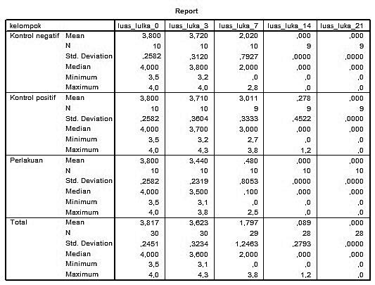

**Uji normalitas data :**





**NPar Tests**

**Kruskal-Wallis Test**





**NPar Tests**

**Kruskal-Wallis Test**





**NPar Tests**

**Mann-Whitney Test**





NPAR TESTS

/M-W= luas_lulka_0 luas_luka_3 luas_luka_7 luas_luka_14 luas_luka_21 BY

kelompok(1 3)

/MISSING ANALYSIS.

**NPar Tests**

**Mann-Whitney Test**





**NPar Tests**

**Mann-Whitney Test**





**Oneway (Luas luka_3 data berdistribusi normal)**







**Post Hoc Tests**



**Homogeneous Subsets**

