Table 1. Random primers used in this study
No. | Primer | Sequence (5’- 3’) | Usage | Reference
1 | OPA-15 | TTCCGAACCC | marker for male Nepenthes mirabilis | Mokkamul et al. (2007)
2 | OPP-15 | GGAAGCCAAC | marker for female Nepenthes mirabilis | Enjelina et al. (2018)
3 | OPO-08 | CCTCCAGTGT | marker for male Trichosanthes dioica | Kumar et al. (2008)
4 | OPP-08 | ACATCGCCCA | marker for male Salacca zalacca | Parjanto et al. (2006)
5 | OPK-16 | GAGCGTCGAA | marker for male Nepenthes ampullaria | Enjelina et al. (2018)

Table 2. Polymorphism of PCR-RAPD bands in Nepenthes adrianii from Baturraden Botanical Garden
Primer | Number of Monomorphic Bands | Number of Polymorphic Bands | Total
OPA-15 | 6 | 4 | 10
OPP-15 | 5 | 4 | 9
OPO-08 | 1 | 6 | 7
OPP-08 | 3 | 8 | 11
OPK-16 | 2 | 6 | 8
Total | 17 | 28 | 45
Total | 37.7% | 62.3% | 100%

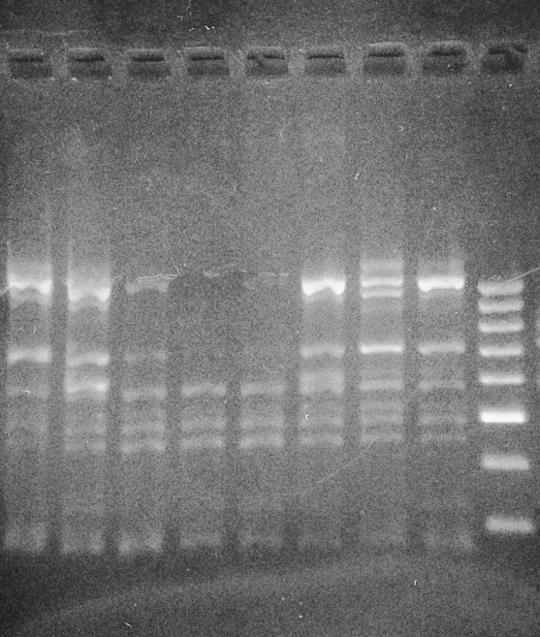
X2 X1 B2 B1 J4 J3 J2 J1 M
500 bp
1,000 bp
300 bp
J1 J 2 J3 J4 B1 B2 X1 X2 M

Figure 1. PCR-RAPD using primer OPA-15 (M = DNA Ladder; J1= male 1; J2 = male 2; J3 = male 3; J4 = male 4; B1 = female 1; B2 = female 2; X1 = unknown sex 1; X2 = unknown sex 2)

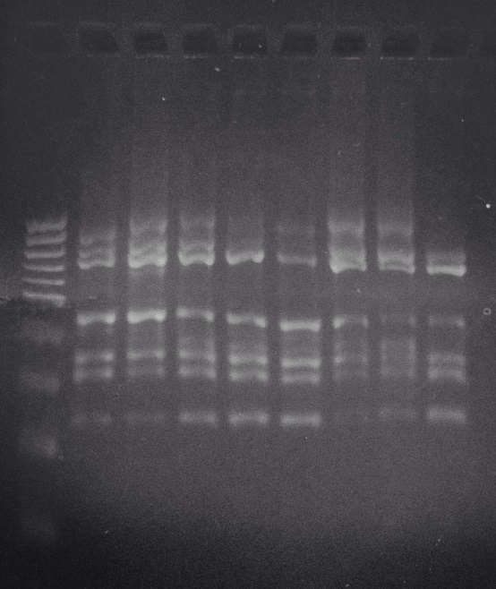
M J1 J 2 J3 J4 B1 B2 X1 X2
500 bp
300 bp
1,000 bp

Figure 2. PCR-RAPD using primer OPP-15 (M = DNA Ladder; J1= male 1; J2 = male 2; J3 = male 3; J4 = male 4; B1 = female 1; B2 = female 2; X1 = unknown sex 1; X2 = unknown sex 2)
200bp

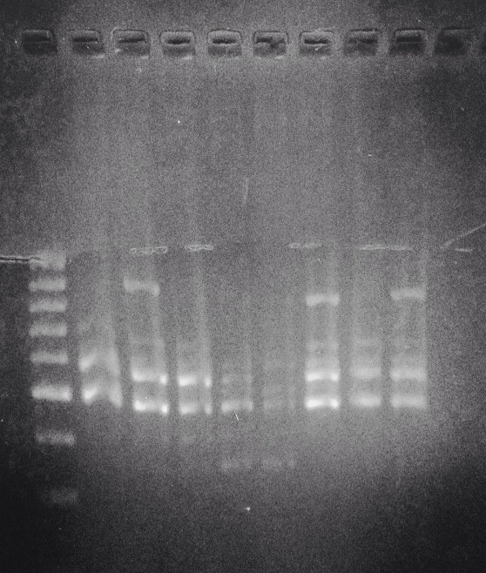
M J1 J 2 J3 J4 B1 B2 X1 X2
1,000 bp
500 bp
300 bp

Figure 3. PCR-RAPD using primer OPO-08 (M = DNA Ladder; J1= male 1; J2 = male 2; J3 = male 3; J4 = male 4; B1 = female 1; B2 = female 2; X1 = unknown sex 1; X2 = unknown sex 2)

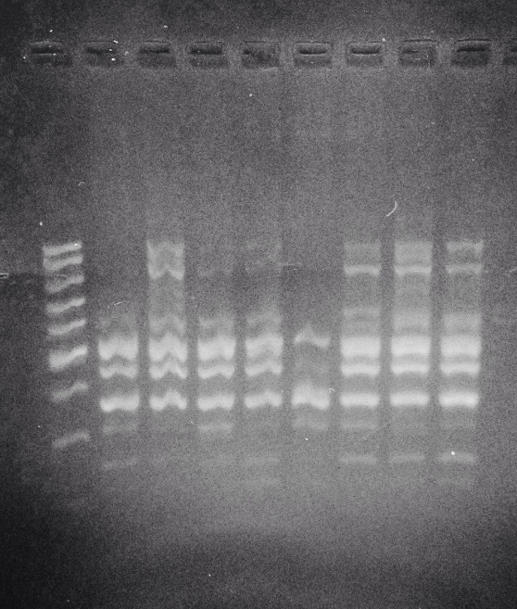
M J1 J 2 J3 J4 B1 B2 X1 X2
1,000 bp
500 bp
300 bp

Figure 4. PCR-RAPD using primer OPP-08 (M = DNA Ladder; J1= male 1; J2 = male 2; J3 = male 3; J4 = male 4; B1 = female 1; B2 = female 2; X1 = unknown sex 1; X2 = unknown sex 2)

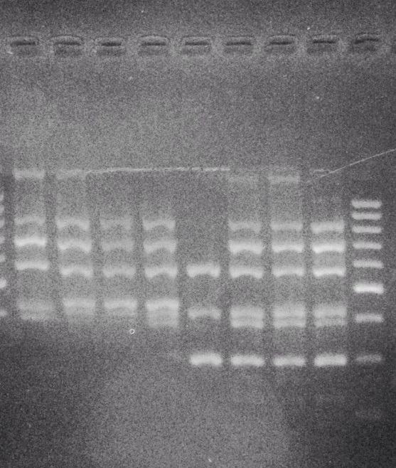
J1 J 2 J3 J4 B1 B2 X1 X2 M
500 bp
1,000 bp
300 bp

290bp

Figure 5. PCR-RAPD using primer OPK-16 (M = DNA Ladder; J1= male 1; J2 = male 2; J3 = male 3; J4 = male 4; B1 = female 1; B2 = female 2; X1 = unknown sex 1; X2 = unknown sex 2)

