**E:\Progress Report\Neotypyfication\1802188.JPG**

Figure 1. Neotype of *Smilax klotzschii* Kunth, Koorders 34990β (BO)

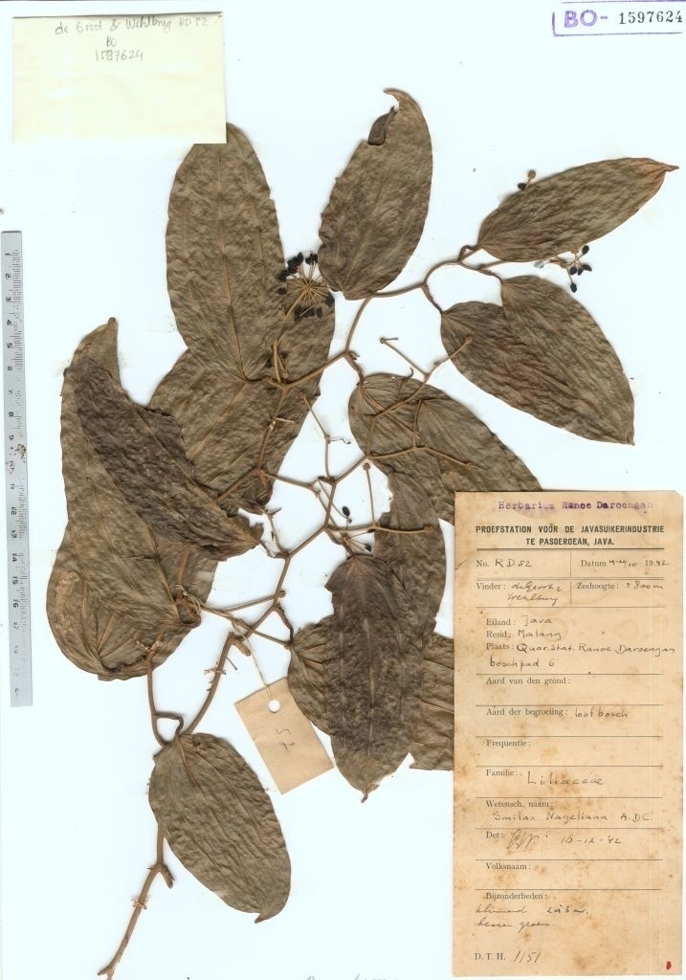

Figure 2. Neotype of *Smilax nageliana* A.DC, de Groot & Wehlburg RD52 (BO)

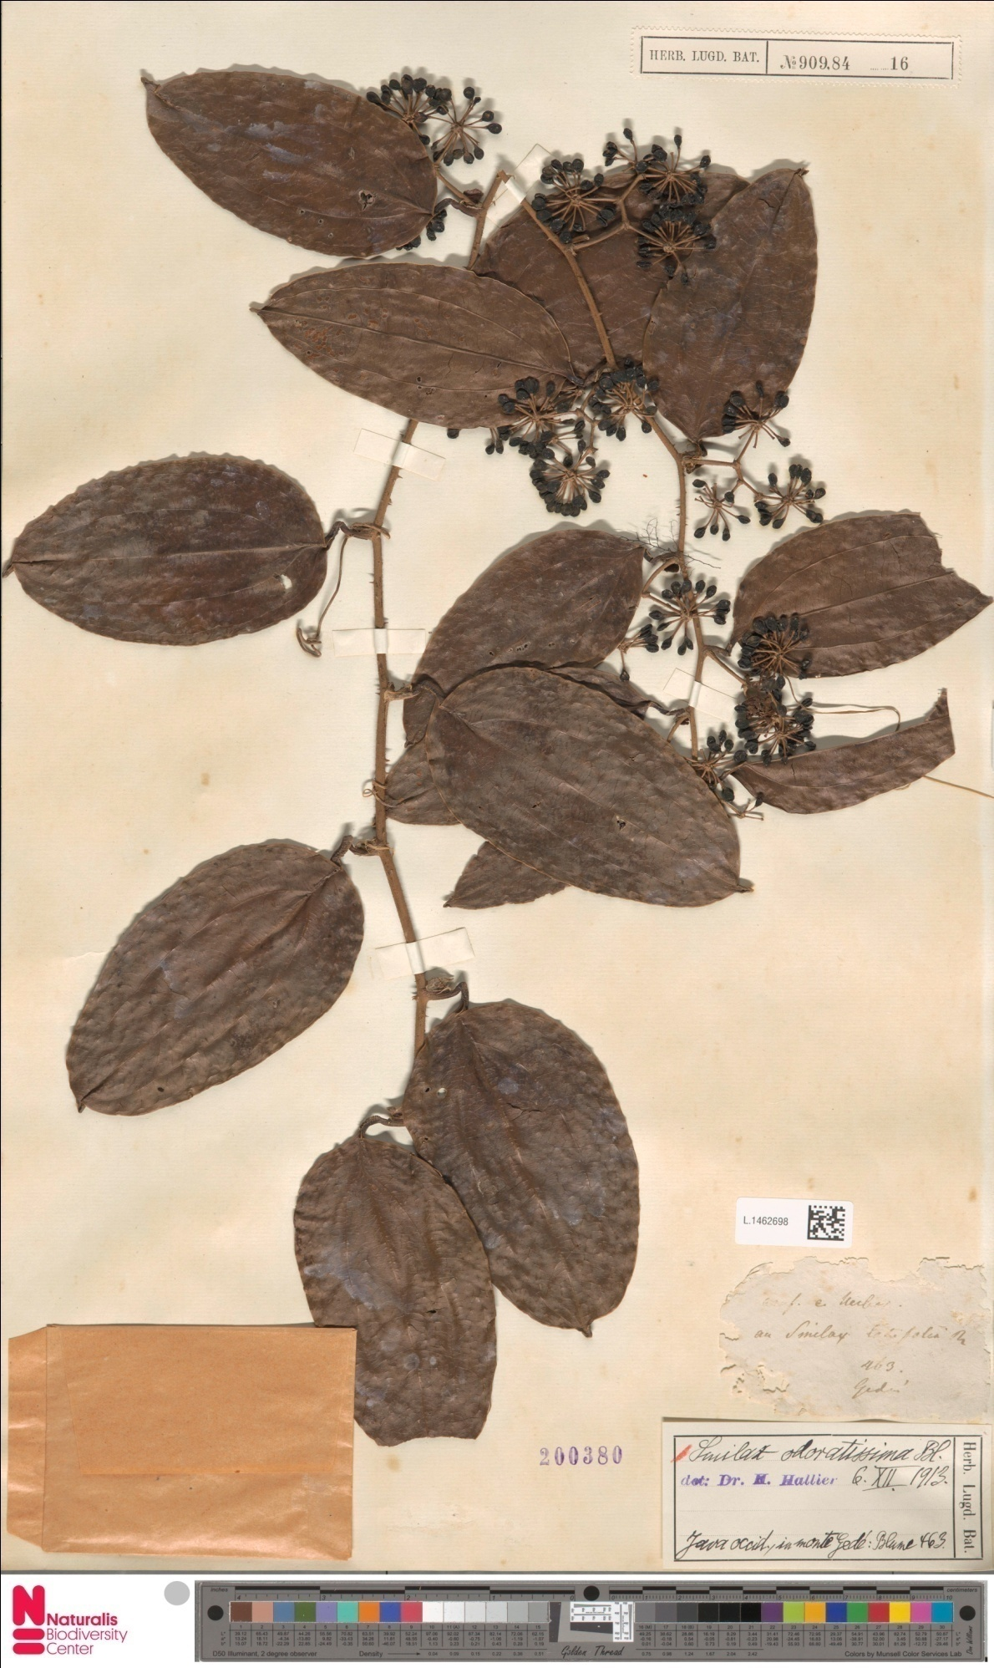

Figure 3. Neotype of *Smilax odoratissima* Blume, Blume 463 (L)