**TEACHERS’ STRATEGIES IN TEACING READING**

**AT SMP SWASTA MULIA PRATAMA**

***Yosi D Lumban Gaol1, Ribka Debora Grace N2, Bellaudri Sri Anzelina3***

***Prima Indonesia Universitiy***

[*lumbangaolyossy@gmail.com*](mailto:lumbangaolyossy@gmail.com)

[*grace2702ginting@gmail.com*](mailto:grace2702ginting@gmail.com)

[*bellasry1998@gmail.com*](mailto:bellasry1998@gmail.com)

**ABSTRACT**

Strategies teaching reading is the ways that teachers used in teaching reading to attract students’ attention to learning reading in the classroom. The reserach was conducted to find out the strategies of the teachers in teching reading, how the teachers applied the strategies in teaching reading, and the reason of the teachers applied the strategies in teaching reading at eight grade SMP Swasta Mulia Pratama.

The researchers used descriptive qualitative method. The subject of this research was english teacher at seven grade SMP Swasta Mulia Pratama. The instruments of this research were classroom observation and interview.

The researchers find out the teachers’ strategies in teaching reading, namely Reciprocal Teaching Strategy, QARs strategy. How the teachers applied the strategies in teaching reading. Firstly, teacher read the text two three times, after that teacher asked the students about type of the text. If no one from the students can’t to answered, the reacher will gave the explaination. Secondly, teachers should told students to underlined the difficlties words and find out the meaning of the words. Students can form a group to discuss the text that they were read. Then, The teacher will asked the students to answer the questions one by one, after the teacher repeated reading a sentence or vocabulary that is difficult to pronounce.And the last one, the teacher gave some questions one by one of the students or asked students to read one paragraph or some sentences for every student.The reason for using the strategies so that the students were more focused and can easily understand the meaning of the texts, and teacher more easily to teaching reading in the classroom.

***Keywords : Strategies, Teaching, Reading***

**ABSTRAK**

Strategi mengajar membaca adalah cara yang digunakan guru dalam mengajar membaca untuk menarik perhatian siswa untuk belajar membaca di kelas. Penelitian ini dilakukan untuk mengetahui strategi guru dalam mengajar membaca, bagaimana guru menerapkan strategi dalam mengajar membaca, dan alasan guru menerapkan strategi dalam mengajar membaca di delapan kelas SMP Swasta Mulia Pratama.

Para peneliti menggunakan metode deskriptif kualitatif. Subjek penelitian ini adalah guru bahasa Inggris di kelas tujuh SMP Swasta Mulia Pratama. Instrumen penelitian ini adalah observasi kelas dan wawancara.

Para peneliti menemukan strategi guru dalam mengajar membaca, yaitu Strategi Pengajaran Reciprocal, strategi QARs. Bagaimana para guru menerapkan strategi dalam mengajar membaca. Pertama, guru membaca teks dua tiga kali, setelah itu guru bertanya kepada siswa tentang jenis teks. Jika tidak ada seorang pun dari siswa yang tidak dapat menjawab, guru akan memberikan penjelasan. Kedua, guru harus memberi tahu siswa untuk menggarisbawahi kata-kata kesulitan dan mencari tahu arti kata-kata itu. Siswa dapat membentuk kelompok untuk mendiskusikan teks yang mereka baca. Kemudian, Guru akan meminta siswa untuk menjawab pertanyaan satu per satu, setelah guru mengulangi membaca kalimat atau kosa kata yang sulit diucapkan. Dan yang terakhir, guru memberikan beberapa pertanyaan satu per satu siswa atau meminta siswa untuk membaca satu paragraf atau beberapa kalimat untuk setiap siswa. Alasan untuk menggunakan strategi sehingga siswa lebih fokus dan dapat dengan mudah memahami makna teks, dan guru lebih mudah untuk mengajar membaca di kelas.

***Keywords : Strategi, mengajar, membaca***

**INTRODUCTION**

**Background of Study**

Strategies teaching reading is the ways that teachers used in teaching reading to attract students’ attaention to learning reading in the classroom. There are many strategies that teachers can use when they are teaching reading comprehension. Some of them are by using authentic material and approaches, reading aloud in the classroom, comprehension question, before teaches in the class the teachers must check up the difficult level of the text . In addition, teachers also may use another strategies such as developing vocabulary of children, not to continue reading without understanding, grasping the heart of matter, using contextual clues, teach reading strategies, visualizing what is written, provide a variety of reading purpose, identify texts and tasks, and so on. Factually, as seen that there are many teachers who did not know how to teach English, especially in teaching reading comprehension.

Researchers choose a title about Teachers’ Strategies in Teaching Reading at SMP Swasta Mulia Pratama because researchers want to learn how a good strategy for students so as to overcome the weaknesses experienced by students when receiving learning reading.Through this research, researchers hope to learn a good strategy for teachers to perform in teaching reading so that students are able to receive learning well and quickly. To overcome the difficulties of teachers in applying strategies in teaching reading.

**Problem (s) of Study**

Based on the background the problem of this study were formulated as :

What are strategies that use by the teachers in teaching reading at SMP Swasta  Mulia Pratama?

How the teachers apply reading strategies in teaching at SMP Swasta Mulia Pratama?

Why the teachers apply reading strategies in teaching reading at SMP Swasta Mulia Pratama?

**Objective (s) of Study**

The objective of this study were to find out :

The strategies that use by the teachers in teaching reading at SMP Swasta Mulia Pratama.

The strategies apllied by the teacher in teaching reading at SMP Mulia Pratama.

The cause of the teachers applied the strategies teaching reading at SMP Mulia Pratama.

**Scope of Study**

The scope of the study has been limited just the teachers’ strategies in teaching reading at seven grade of SMP Swasta Mulia Pratama, mean planning of the teacher in teaching reading to improve student’s ability in understanding reading written text english or printed material.

**Significance of Study**

The significance of the study were be useful for :

*The teacher*

The teacher easier in teaching reading, especially to give the ways to attract students’ attention to learning reading in the classroom.

*The Students*

The students more easily to understand what the meaning of the text from the strategies that used by the teachers and can increased students consetration.

*The Researchers*

This research will be useful to improve english teaching especially have knowledge in teaching reading.

**LITERATURE REVIEW**

**Defenition of reading**

The researh was conducted to find out teachers’ strategies in teaching reading as following :

Ahmad (2013) state that the teachers apply three kinds of stages in teaching reading there are pre-reading, while reading, and post-reading stages. In pre-reading stage they give the students some questions as a worming up to know and write the students vocabulary mastery. This is also do to help the students to enter to the topic to discuss. Next, in while reading stage, the distribute the texts and give some questions relate to the next provide. This is do to know the students’ comprehension on the text give. Even, this is do through apply. In teaching reading there are many activities that can be doing especially when the process of teaching-learning in the class. Jeremy Harmer (2008) defined that teaching is not easy job, but it is necesarry one, and can be very rewarding when the teachers see their students comprehension and know that the teachers have helped to make it happen.

**Strategies in teaching reading**

Reading is the one of ways to make the students understand in teaching-learning process in the class. The teachers have some ways to attract students’ attention so the students interest to following the reading lesson in the class. Every students has different characters to following the lesson in the class, so the teachers must have brilliant ideas to overcome this problem.There are strategies in teaching reading that used by the teacher at seven grade SMP Swasta Mulia Pratama, namely :

**Reciprocal Teaching**

Reciprocal Teaching is the strategy to develop skills that use the teacher with four skills strategies to read the text, namely question generating, clarifying, predicting, and summarizing, so the students easier to understanding the meaning of the texts.

**QARs**

QARs is a reading strategy through understanding and analysis of questions. In other words this strategy guides students to understand the questions in order to get an information in a reading itself. So that in practice in the classroom students only glance read the reading and to understand further the focus of students is the questions given by the teacher about the text reading.

**RESEARCH METHOD**

**Research Design**

This research used descriptive qualitative design. The research used to desribe the real condition in phenomenon. This research was conducted on 2 stages. teachers and students. And there are 2 research techniques for collecting data, namely classroom observation and questionnaires. The researchers will conduct observations to observe the teaching-learning process in the class. And then, the researchers do an interview with the teacher to get the data about teaching reading.

**Place and Study**

The research was located at SMP on SwastaMuliaPratama at Jahe Raya street No.10.

And the research planning is on Monday, 11th November 2019

**Instrument of Collecting Data**

The researchers used two instruments to collected data :

***Classroom Observation***

Classroom Observation is One effective mean of learning how certain teaching methods are employed in the schools, how classroom are organized, and how students respond the classroom environment (Reed & Bergemann, 2005, 9).

***Interview***

Interview is an conversation between interviewer and interviewee that useful for asking adn giving information related to a problem or material.

**Technique of Collecting Data**

The data collected by some procedures, such as :

* The researchers came to the class. We will collected the data with the classroom observation technique.
* The researchers prepared the research instrument, in this case recording item.
* The researchers recorded the teacher while the teacher teaches in the class.
* Reseachers observed the teacher for 80 minutes.
* Afterthat, the researchers will continued with conducted an interview between researchers and the teacher , for asking and giving information.
* The researchers giving 10 questions to the teacher, about how to teaching reading in the class.

**Technique of Analyzing Data**

The data collected will be analyzed by the researchers. The researchers desired the strategies used by the teacher in teaching reading. When the researchers is observing in the classroom, the researchers must examine how the strategy is done by the teachers in teaching reading and how students’s attitudes to following the lesson.Researchers already know several strategies, how to make good teacher, strategies so students can receive lesson well. Because, in this position students may pay less attention, or there are those who are lazy to learn, there is also the ability to catch students who are not good. Otherwise, it could be because the teacher lacks understanding of using strategies in teaching reading, so some students can not understand the lesson well. After that, the reserachers will collect data consisting of questionnaires answered by students, between agree, doubt, and disagree. Students certainly differ from one another. Through observation of teaching and learning activities in the previous class, of course researchers already know which students really follow the lesson well. Then, the data will be summerized in the table.

**FINDING AND DISCUSSION**

**Finding**

All data from this study were obtained by Classroom Observation and Interview. The researcher interviewed the english teacher from SMP Swasta Mulia Pratama. The data collected through classroom observation. The researchers observe the English teacher when teaching in the classroom. Data that was not revealed through classroom observation, so the researchers also interview teacher after teaching from the class.From the data collected and analyzed the research desired the strategies used by the teacher in teaching reading. They are Reciprocal Teaching and QARs.

**Discussion**

Based of the result showed that the strategies that the teacher used in teaching reading at SMP Swasta Mulia Pratama were two strategies, Reciprocal Teaching(1), and QARs (Question Answer Relationship) (2). The teacher used these strategies to help students understand reading texts. They Students not only read, but are able to understand the text they are reading. With those strategies the teacher guides students to focus more on developing ideas in understanding the contents of the text. The application made by teachers at SMP Swasta Mulia Pratama. For students’ understanding of the text, the teacher used reciprocal teaching strategy. For develop students’ ideas the teacher used QARs strategy in understanding the contents of the text.

1. Reciprocal Teaching

Reciprocal Reaching is reciprocal strategy. This strategy is an activity of giving instruction to the students. The teacher gave the opportunity to students to form a group and they will discuss the text they are reading. Each group members look for reading difficulties in the text. Students will mark vocabulary/sentence that is difficult to read it. After that the group will discuss how to read the difficult vocabulary/sentence. If they group is still experiencing difficulties, they can ask to the teacher, and the teacher will calrify by giving an explanation to the students. The purposes of the strategies are to help, to bulid, and to support students’ understanding in reading texts.

There are four skills strategies to understanding in reading texts by reciprocal teaching strategy, namely :

Summarizing

Predicting

Question

Generating

Clarifying

Pupils identify the information contained in the text according to what was discussed with the group.

Pupils make concerted attempts to clarity concepts or vocabulary that is not understood

Pupils must ask the teacher if they not understand the difficult concept and teacher clarifying by giving answers

Pupils conceptualize questions about the reading text that will be discussed with their group.

Through classroom observation, the researchers used this strategy. The teacher gives instructions to the students to form groups. Each group consists of 5 members, and there are 5 groups. Although not all students are so focused, but mostly students ask the teacher that they dont understand how to read from the text. Like, *“Bu, bagaimana cara membaca bahasa inggris warna?”(color) “Bu, membaca bahasa inggris lantai, bagaimana?”(floor).* Then, the teacher will explain each question from the group. After they have fnished the discussion, otherwise the teacher will ask students about the text. If students

Are able to asnwer, then students already understand. However, if students dont anderstand, they teacher will repeat asking questions until students are able to answer until they understand the text.

1. QARs

This strategy is a question and answer was gave by the teacher to observed how the students understand the text that they read first, after the teacher guides students by first reading the text that will be understand by students. Then, the teacher gave questions to the students, afterwhile they should write their answers in their books with their own word. The teacher will asked the students to answer the questions one by one, after the teacher repeated reading a sentence or vocabulary that is difficult to pronounce.

Based of the researh were conducted by the researchers that the teacher used this strategy to know how far the students understand the contents of the text. For example *“what was the meaning of berbicara? meaning of Jingga? Lantai? Pagar? Gang?”*. If students can answer the question given by the teacher, they understand the text. However, if students cannot answer questions from the teacher, they do not understand the text. This strategy will greatly help students, if they are able to answer questions using their own words. Otherwise, this strategy will not help if students answer questions with the help of friends or ideas from friends.

Based of result and discussion, researchers have an analysis that occurs in the classroom during the learning process. The teacher helps students by translating words that are difficult for student to know, and the teacher will repeat words that are difficult to pronounce. This is the teachers’ strategies, after the teacher read the text, one by oen of students were given the task to read the text one paragraph. Then, the students are directed to focus when the teacher reads the text so that the students were easier understanding the context of reading text.

**CONCLUSION AND SUGGESTION**

**Conclusion**

From the result of the data and data analysis, the researcher concluded that the teachers’ strategies at seven grade SMP Swasta Mulia Pratama Medan are Reciprocal Teaching and QARs. How the teachers applied the strategies in teaching reading. Firstly, teacher read the text two three times, after that teacher asked the students about type of the text. If no one from the students can’t to answered, the reacher will gave the explaination. Secondly, teachers should told students to underlined the difficlties words and find out the meaning of the words. Students can form a group to discuss the text that they were read. Then, the teacher will asked the students to answer the questions one by one, after the teacher repeated reading a sentence or vocabulary that is difficult to pronounce. And the last one, the teacher gave some questions one by one of the students or asked students to read one paragraph or some sentences for every student . The reason for using the strategies so that students were more focused and can easily understand the meaning of the texts, and teacher more easily to teaching reading in the classroom.

**Suggestion**

The researchers have some suggestions it is hopefully be useful for :

*The Teachers*

The researchers hoping the english teachers maintain the quality of teaching. And apply other teachers’ strategies, which aim to maintain students willingness to learn. Because this is the teaching goals in teaching-learning process.

*The students*

With teachers’ strategies that used by the teacher, hoping the students more focus, so more easily to understand about reading text.

*The next researchers*

The researchers wishes that next researcher can conducted the research in a wider scope. So the next researcher find out other interesting strategies that applied by the teachers in teaching reading.

**ACKNOWLEDGEMENT**

Praise and thanks the Lord Jesus Christ for being a supporter, inspiration, faithful friend of the researchers. The researchers have been grateful, through this research, we have able to publish a journal education article. We also thanks to our lectures in Prima Indonesia University especially to the lectures Faculty of Teaching and Training of English Department. To headmaster and english teachers, who have given us oportunity to conducted observation at SMP Swasta Mulia Pratama Medan. We also thanks to Mrs. Yenita Br Sembiring, S.S., M.Hum. as our advisor lecture because always gives a lot of guidance to completed this journal education. Moreover, our thanks also to our parents always gives support and to our friends.

**BIBLIOGRAPHY**

Mukhroji, M, *The Importance of Teaching Reading Strategies to Improve Students Reading Comprehension*. Malang: State university of MalangPress, 2011

Nurhamidah, Siti, *An Analysis of Teachers’Strategies in Teaching Reading Comprehension at SMAN 2 Padang Bolak* [*https://s.docworkspace.com/d/ABhiY6GR2t01woPE3M2mFA*](https://s.docworkspace.com/d/ABhiY6GR2t01woPE3M2mFA)*.* 2018

Sarjan, Nurmadia, *An Analysis on The English Teachers Strategies in Teaching Reading Comprehension at the second grade Students of Junior High School 1 of Wonomulyo* [*https://s.docworkspace.com/d/ADMptyuR2t01oujF3M2mFA.{thesis}*](https://s.docworkspace.com/d/ADMptyuR2t01oujF3M2mFA.%7bthesis%7d)*.* 2017

Ulker,Unal, *reading Comprehension Strategies*[*https://s.docworkspace.com/d/AD5EZ92R2t01oq7M3M2mFA. 2017*](https://s.docworkspace.com/d/AD5EZ92R2t01oq7M3M2mFA.%202017)

Sugiono, *Metode penelitian keantitatif, kualitatif dan R&d.* Bandung: Alfabeta, 2009

Antoni, Nurman *Exploring efl Teachers’ strategies in teaching reading compehension*[*https://s.docworkspace.com/d/APSsxGCR2t01wvPQ3M2mFA*](https://s.docworkspace.com/d/APSsxGCR2t01wvPQ3M2mFA)*.* 2010

Muslaini, *Strategies for Teaching Reading Comprehension*[*https://s.docworkspace.com/d/AB9-e7OR2t01ooHZ3M2mFA*](https://s.docworkspace.com/d/AB9-e7OR2t01ooHZ3M2mFA)*.* 2017

Koeswiryono, Dika Pranadwipa *the teaching adn learning process of reaning comprehension to students with Visual Inveronment*[*https://s.docworkspace.com/d/ABYufPmR2t014uve3M2mFA*](https://s.docworkspace.com/d/ABYufPmR2t014uve3M2mFA)*.* 2012

**APPENDIX**

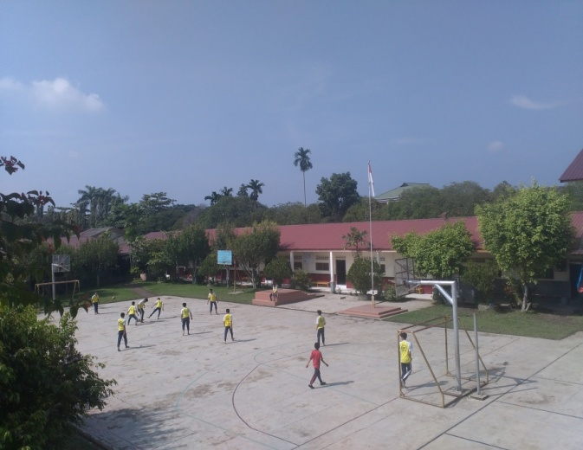**Picture of SMP Swasta Mulia Pratama**

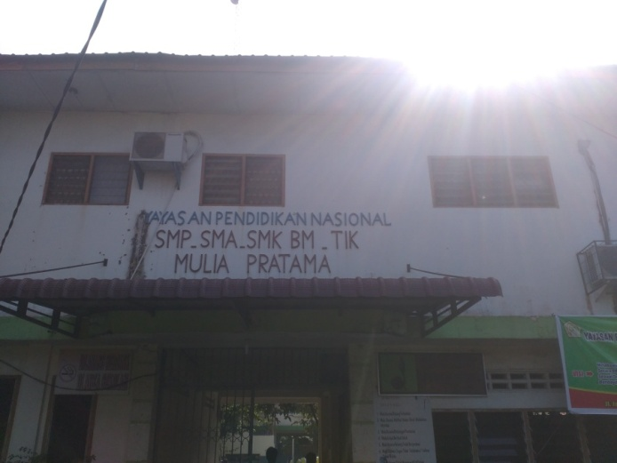

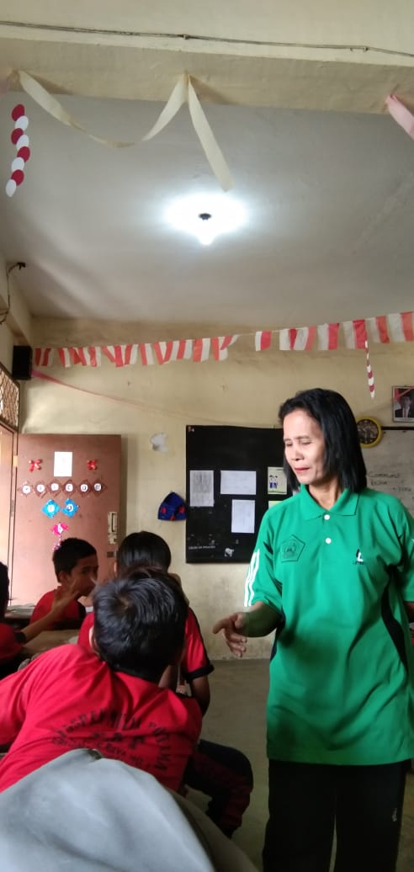 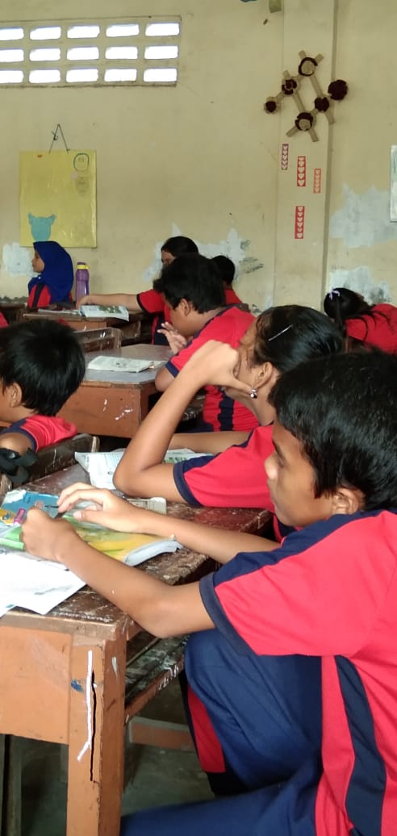

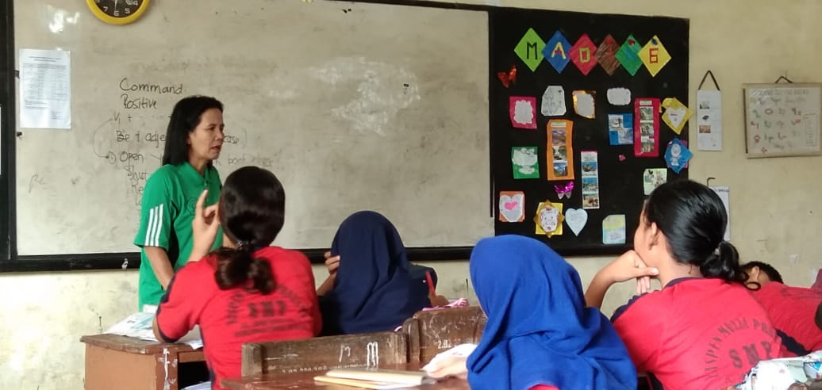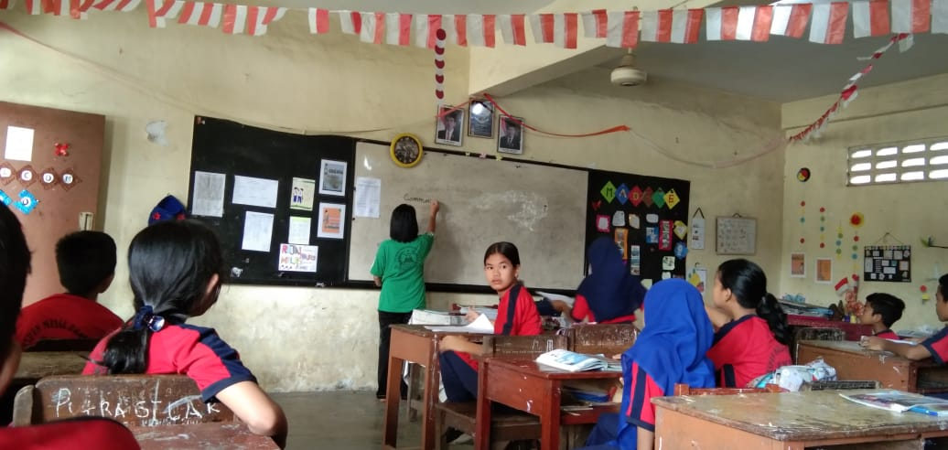

**Permit letter from University**

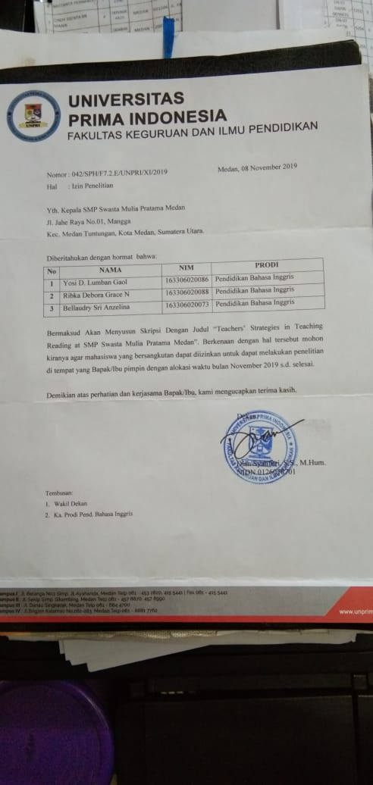

**Reply Letter from SMP Swasta Mulia Pratama**

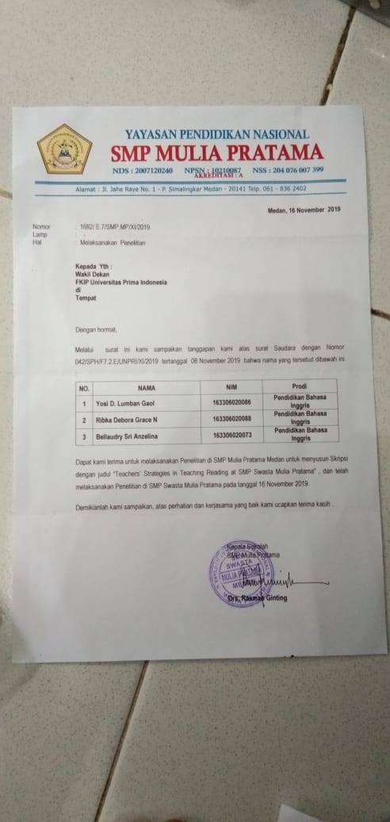

**Interview Transcription**

**TRANSKIP WAWANCARA**

Nama Sekolah : SMP Swasta Mulia Pratama, Medan

Waktu Wawancara : Sabtu, 16 November 2019, 10.00-10.25

Tempat Wawancara : Ruang Guru

Masalah           : Teachers’ Strategies in Teaching Reading

Responden : Guru Kelas VIII (Dra. Lina Saragi)

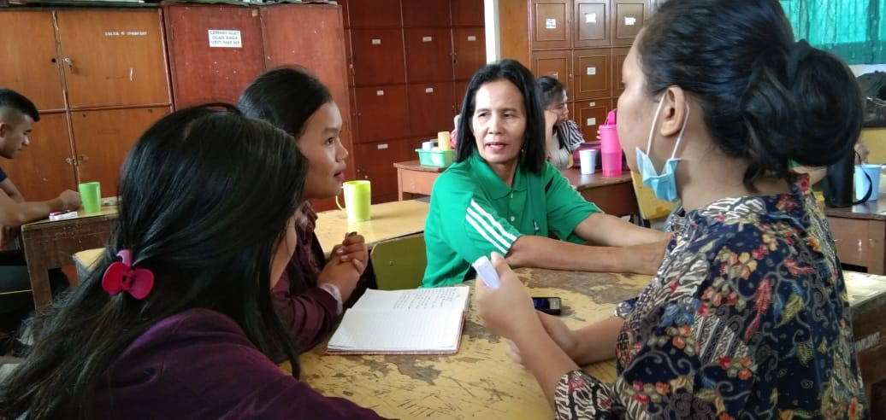

1. Mengapa beberapa siswa kesulitan belajar membaca?

:Karena bahasa Inggris bukan bahasa kedua melainkan bahasa asing sehingga murid tidak memiliki dasar untuk berbahasa inggris dari sejak kecil

1. Apa kendala siswa dalam belajar membaca?

:Pelafalan kata, intonasi, pengucapan yang berbeda dengan apa yang ditulis

1. Sebagai guru, apa yang anda lakukan untuk membantu siswa yang kesulitan belajar membaca?

:Dapat dilakukan dengan mengamati perilaku anak dan kemampuan anak dalam aktivitas menulis, membaca, berhitung dan mengeja. Pengamatan dilakukan untuk mendapatkan informasi awal dan selanjutnya dilakukan asesmen yang meliputi asesmen perkembangan, akademik, non akademik, formal dan informal.

1. Metode apa yang anda gunakan untuk mengajar membaca kepada siswa?

:Pertama tama saya terlebihi dahulu membaca teks yang ada, lalu saya menyuruh siswa satu persatu untuk mengucapkan apa yang saya bacakan diawal. Selain itu saya juga mengajak siswa belajar membaca dengan cara membaca buku cerita, membaca syair lagu supaya siswa lama kelamaan terbiasa dan bisa membaca dengan baik.

1. Sudah berapa lama anda menggunakan metode pengajaran tersebut?

: Kurang lebih sudah 2 tahun saya menggunakan metode ini

1. Bagaimana anda mengetahui kemampuan membaca siswa?

: Awalnya saya membaca dan menyuruh siswa membaca ulang apa yang saya baca.   Dari situ kita bisa tau mana siswa yang mampu dan kesulitan dalam membaca

1. Seberapa sering anda menyuruh siswa membaca teks bacaan yang ada di buku panduan belajar?

: Saat mengajar dikelas saya selalu menyuruh siswa membaca secara bergantian

1. Apa yang menyebabkan siswa sulit dalam pengucapan bahasa inggris?

: Karena dalam bahasa inggris ada pelafalan yang agak susah, dan pengucapan yang    tidak sesuai dengan kata yang ditulis dalam teks

1. Apa yang harus dilakukan untuk menumbuhkan minat baca siswa?

: Sering sering mengajar membaca dengan menggunakan buku cerita seperti teks narrative, recount, dan legend

1. Strategi apa yang anda lakukan di kelas jika ada beberapa siswa yang kesulitan membaca? tetapi malas membaca?

: Awalnya saya memberitahukan kepada siswa seberapa penting bahasa inggris di kehidupan sekarang ini dan memang itu sangat berguna jadi saya memotivasi siswa supaya niat belajar membaca. Saya juga selalu mengajarkan kepada siswa jika ada pelafalan dan pengucapan yang agak susah. Saya juga membuat siswa belajar tidak mononton seperti jaman dulu yang hanya terfokus pada guru. Saya mengajak siswa untuk aktif dan berani untuk berbicara terlepas dari pengucapan yang benar atau salah dan saya berserta murid murid bersama-sama untuk memperbaikinya.