**STUDENTS’ DIFFICULTIES IN LISTENING COMPREHENSION**

**AT SMP SWASTA KENANGA MEDAN**

**Elma J Pakpahan1, Silvia A Simbolon2**

***Prima Indonesia University***

***1***[***elmapphn@gmail.com***](mailto:elmapphn@gmail.com)

***2***[***silviasimbolon1998@gmail.com***](mailto:silviasimbolon1998@gmail.com)

**ABSTRACT**

Listening is the skills in learning English language. listening help us to understand and master language skill and make learners easier to communicate in that language.

The aim of this research were to find out : Students’ Difficulties in Listening Comprehension at SMP Swasta Kenanga Medan and the English teacher solution in overcome the difficulties that experienced by students. this research performed in SMP Swasta Kenanga Medan at eighth grade. researchers used qualitative research designs. the data collected by listening test, questionnaire and interviews.

Based on students test result, researchers found that 9 from 14 students in eighth grade experienced difficulties in listening comprehension, and the data from questionnaire showed most of students found difficulties when listening comprehension. From the interview among researchers with English teacher, the English teacher solution were : listening to English song, watching cartoon movie etc.

***Keywords : Difficulties, Listening, Comprehension, Solutions***

**ABSTRAK**

Listening adalah keterampilan dalam belajar bahasa Inggris. Listening membantu kita untuk memahami dan menguasai keterampilan bahasa dan membuat pelajar lebih mudah untuk berkomunikasi dalam bahasa tersebut.

Tujuan dari penelitian ini adalah untuk mengetahui: Kesulitan Siswa dalam Pemahaman Listening di SMP Swasta Kenanga Medan dan solusi guru bahasa Inggris dalam mengatasi kesulitan yang dialami oleh siswa. Penelitian ini dilakukan di SMP Swasta Kenanga Medan pada kelas delapan. peneliti menggunakan desain penelitian kualitatif. data dikumpulkan dengan tes Listening, kuisioner dan wawancara.

Berdasarkan hasil tes siswa, peneliti menemukan bahwa 9 dari 14 siswa di kelas delapan mengalami kesulitan dalam pemahaman Listening, dan data dari kuisioner menunjukkan sebagian besar siswa menemukan kesulitan pada saat pemahaman Listening. dari wawancara antara peneliti dengan guru bahasa Inggris, solusi dari guru bahasa Inggris adalah : mendengarkan lagu bahasa Inggris, menonton film kartun dll.

***Kata kunci: Kesulitan, Mendengarkan, Pemahaman, Solusi***

**INTRODUCTION**  
**Backgruond of Study**

One of the four main language skills in learning English is Listening. it plays an important role in learning the language and helps the students to enhance their knowledge because the students learn many things through listening. The students to master other language skills , such as speaking, reading, and writing also supports of listening. Listening enables them to get new information which makes them easier to communicate in that language. In addition, listening can entertain the students, because it is not only applied for academic purposes, but also helps the students to refresh their mind. In another word, listening is very crucial in teaching and learning the language, but in fact many students especially junior high school have difficulties when learn listening that is why the researchers interested to choose this research entitle “ Student’s Difficulties In Listening Comprehension at SMP Swasta Kenanga Medan.

Through this study the reseachers hope that students especially in junior high school who have difficulties in listening comprehension get new knowledge about listening in order to grind their abilities and improve the difficulties that experienced by students when listening comprehension. The advantage of this research is because this research will be very beneficial. In this research provide some manners to overcome the learning difficulties that experienced by students in junior high school and to improve the abilities of students in listening comprehension. Because most of the students have some difficulties in learn listening comprehension. And the disadvantage of the research if not do is students perception about listening comprehension is always difficult.

**Problem of Study**

What are the students’ Difficulties In Listening Comprehension at SMP Swasta Kenanga Medan?

Why did the students’ at SMP Swasta Kenanga Medan have Difficulties in Listening Comprehension?  
How to overcome the difficulties in Listening Comprehension that students experienced at SMP Swasta Kenanga Medan?

**Objective of Study**

The objectives of the study were to find out :

The Students’ Difficulties in Listening Comprehension at SMP Swasta Kenanga Medan.

The Cause of Students get difficulties in Listening Comprehension at SMP Swasta Kenanga Medan.

The Solutions to overcome the Difficulties in Listening Comprehension at SMP Swasta Kenanga Medan.

**Scope of Study**

In this research the scope of study is limited just for the students at Eight grade of SMP Swasta Kenanga Medan in Listening Comprehension.

**Significance of Study**

*To the Students*

Students can identify their Difficulties in Listening Comprehension. when students know about their problems, then they will be improve their listening practices and become better listeners.

*To the Teachers*

Teachers have to develop understanding of their students’ Difficulties in Listening Comprehension and examine their teaching methods to improve students’ Difficulties in Listening Comprehension.

*To the Researchers*

This Research will improve the researchers knowledge in listening comprehension especially to know the difficulties that students’ experienced at SMP Swasta Kenanga Medan.

*To the Other Researchers*

Researchers who are interested in class research to use this findings a basis to further study the field.

**THE REVIEW OF LITERATURE**

**The Defintion of Listening**

Many researchers clarify the definition of listening into different meaning. to comprehend or understand native speech in the normal speed was the definition of listening stated by Chastain (1971). meanwhile Morley (1972) stated that listening were involved with discrimination (auditory), grammar (aural), selecting the necessary information, remembering, and connecting it to the process between sound, and meaning form. the differs in meaning form sound discrimination to aural comprehension was the definition of listening stated by Postovsky (1975). according to Goss (1982) stated that listening as a understanding process in what is heard and organizing it into lexical elements to the meaning thet can be allocated. listening is the understanding of the oral language. stated by : Bowen, Madsen, and Hilferty (1985). the process of receiving , making meaning form and the answering to spoken or noverbal messages, defined Purdy (1997). according to Rost (2002) listening was identify as a complex process of interpretation in which listeners match what they hear and what they know.listening is a channel for comprehensible input and more than 50 % of the time that spend by learners in learning listening. Saricoban (1999) stated that listening as the receptive ability which is used to get the productive ability. It is reasonable because the listeners understand the meaning of what they listened, and then they practice to create the language. The integrating language skills build an active in teaching and learning English at the classroom.

Therefore, they can develop their language skills in the real communication. Nation and Newton (2009) say, “In the view of language learning, listening is the way of learning the language. It gives the learners information from which to build up the knowledge necessary for using the language. When this knowledge is built up, the learners can begin to speak.” It is clear that listening is a chance to find out how to get the knowledge which used in language in order to training language in real situation. Thomlison’s (1984) defined that listening is the ability in identify and comprehend / understand what were said. this process involved the understanding of pronunciation and speaker’s accent, the grammar and vocabulary of speakers, and comprehension of meaning in listening.Therefore the students will be able to speak up or using language if they have listening as the way to learn and comprehend language. in this case were an active skill in getting the language not a passive skill.

**The Defenition of Listening Comprehension**

The definition of listening comprehension was stated by many researchers. Brown and Yule (1983) defined that listening comprehension means that the person understand what they heard. if they learns the text by hearing it, then they’ll understand. according to Dirven and Oakeshott-Tylor (1984) listening comprehension of teaching methodology and is matched by terms such as ; speech understanding , spoken language understanding , speech recognition, and speech perception. according to Rost (2002) and Hamouda (2013) listening comprehension as an interactive process in which listeners are involved to construct the meaning. listeners comprehend the oral input by sound discrimination, previous language, grammatical structures, stress and intonation and the other linguistic or non linguistic clues. Nadig (2013) defined listening comprehension as the various processes of understanding and making sense in spoken language. these involve to knowing sound of speech, comprehending the meaning of individual words, and understanding the syntax of the sentences.

**RESEARCH METHOD**

**Research Design**

In this study the method that used is qualitative research with case studies approach. The researhers chosen qualitative method because this research aims to provide insight into cases of anxiety at Smp Swasta Kenanga Medan especially the difficulties that performed by students when they learn listening comprehension. According to Fraenkel and Wallen, case studies are qualitative studies approaches that study one individual, group, or example are important to formulate interpretations for spesific cases or to provide useful generalization. Therefore, the case study approach allows the writer to do it study certain students in an effort to understand cases of difficulties experienced by students in learning to listen. (Bless & Higson-son, 1995 : De Vos, 1998) the qualitative design deals with data that is primarily verbal and derives from meaning the perspective of the participants. its aims to comprehend the meaning which people attached in everyday life.

**The Place and Study**

This research was located on Smp Swasta Kenanga at jln bunga kenanga number 23 Padang bulan Medan.the research is planning on Monday 11th november 2019.

**The Instrument of Collecting Data**

The instrument that used by researchers in this study were :

*Test*

In collecting data the research giving listening test to the students, this test purpose to know the difficulties of students by checking their answers.

*Questionnaire*

Questionnaire of this study is instrument that consist of series questions ( or the other types of prompts). The questionnaire used to identify the dificulties faced by students while listening. The purpose of the questionnaire is to gathering information from respondents.

*Interview*

According to achmadi and narbuo (1991 : 83) interview is the process of direct question answer, where there are two or more people face to face to listen some direct informations or explanations. Researchers need to do interview with english teacher to get some informations about student’s difficulties in listening comprehension at Smp Swasta Medan.

**The Technique of Collecting Data**

In this study the researcher collecting data by listening test, giving questionnaire to students, and interviewing english teacher that consits of some questions about listening comprehension to know the difficulties experienced by them in listening comprehension. questionnaire consists of a series of statements all of which are related to a particular target with asked to the respondents in indicate the extend to which they are agree or disagree. Listening test that use in this research using speaker, and in this study the researchers will interview english teacher at Smp Swasta Kenanga to get more informations about student’s difficulties that student’s experienced.

**The Technique of Analyzing Data**

The data was analyzed by related to the research problems, collecting by gave test, questionnaire and interviewing English teacher. The kind of questionnaire in this research is yes or no questions. The students responded by students in about 15 minutes. In listening test section the researchers will play song audio two times, and then the students will write down ( fill in blanks ) the words that they hear in listening section. the test consist of 10. the assessment consits of five parts, namely : excellent, very good, good, adequate and poor.

**FINDING AND DISCUSSION**

**Finding**

The data that found from this research were :

The students’ answer the test fill in the blanks that given by the researchers. researchers play song entitled “Beautiful in White” twice. through the answers that collected by researchers, 9 from 14 students at eight grade in SMP Swasta Kenanga Medan. Found Difficulties in answer the test.

The Students’ answer from the questionnaire about students’ difficulties in listening comprehension that given by researchers in 15 minutes. From the data that collected by researchers, 12 students found difficulties in understanding unfamiliar vocabulary and when the speaker talking to fast in listening comprehension,11 students found difficulties to understand listening text when the topic is unfamiliar, 8 students found difficulties to interpret meaning of listening that too long and word reduced form in English, 7 students feel difficult to interfere listening comprehension when conversation is too long and 4 students found difficulties to understand the intonation that used by speaker.

The teachers’ answer from the interview given by researchers. the data that collected by researchers from interviewing English teacher were : students found difficulties in listening comprehension when the speaker is native speaker, then when the topic of listening not explain at the previous, and they have obstacle in unfamiliar word.

The solution that given by English teacher were, students must often listening to western song, watching cartoon movie such as, “Finding Nemo” because the pronunciation is easy to understand.

**Discussion**

The data derived from the test, questionnaire and interview then analyzed by the research. From the Analysis of the research, the researchers find out that:

The Students Difficulties in Listening Comprehension at SMP Swasta Kenanga Medan were:

1. Understanding unfamiliar vocabulary
2. Understanding every word spoken while listening
3. When the conversation is too long
4. Interpret the meaning of listening that too long
5. Unfamiliar topic
6. When the speaker is talking too fast
7. Understand word reduced form in English
8. The circumstance at class situation/environment affect their concentration
9. Understand intonation that use by speaker

The reasons that students experienced in difficulties of Listening Comprehension were :

1. Because they aren’t accustomed listening to conversation and song by native speaker.
2. Because they don’t know the topic of listening if the teacher not explain at the previous.
3. Because they’re not develop their vocabularies.

The techniques that should be used in avoiding the students’ difficulties in Listening Comprehension is by using some media, Such as English Song, Watching cartoon Movie such as “Finding Movie” because the pronunciation is easy to understand.

**CONCLUSION AND SUGGESTION**

**Conclusion**

From the result that collected by researchers, 9 from 14 students at eghth grade in SMP Swasta Kenanga found difficulties when listening comprehension through the test. in questionnaire of students’ difficulties at eighth grade in SMP Swasta Kenanga Medan, there were 12 students who find out difficulties to understanding unfamiliar vocabulary and the speed of the speaker when talking in listening comprehension. from the interview among researchers and English teacher. the students’ difficulties in listening comprehension were : when the speaker is native speaker, the unfamiliar topic, unfamiliar words and the reduced form like : “I will” become “I’ll” and “I have” become “I’ve”, etc.

**Suggestion**

After done the research about students’ difficulties in listening comprehension the researchers suggest :

For the teacher

The teacher should be know the results of this research was to know and identify students’ difficulties in listening comprehension at smp swasta kenanga to understand the strategies / solution to overcome the students’ difficulties.

For the students

The students should know their difficulties to improve their comprehension in listening comprehension and also to find the manner to repair their difficulties while listening comprehension.

For other researcher

The other researcher that interested to continue this research to know students’ difficulties and can develop this research better.

**ACKNOWLEDGEMENT**

Praise and thanks the Lord Jesus Christ for being a supporter, inspiration, faithful friend of the researchers. The researchers have been grateful, through this research, we have able to publish a journal education article. We also thanks to our lectures in Prima Indonesia University especially to the lectures Faculty of Teaching and Training of English Department. To headmaster and english teachers, who have given us oportunity to conducted observation at SMP Swasta Mulia Pratama Medan. We also thanks to Mrs. Yenita Br Sembiring, S.S., M.Hum. as our advisor lecture because always gives a lot of guidance to completed this journal education. Moreover, our thanks also to our parents always gives support and to our friends.

**REFERENCES**

Gilakjani, Abbas Pourhosein. Banou, Narjes. *Learners Listening Comprehension Difficulties in English Language Learning : A Literature Review in Iran*, vol. 9 May, 2016. <https://www.researchgate.net/publication/302064830_Learners'_Listening_Comprehension_Difficulties_in_English_Language_Learning_A_Literature_Review>

Asmawati, Andi. Darti. *Analyzing Students’ Difficulties Toward Listening Comprehension in Makassar,* vol. 3, December, 2017.

<http://journal.uin-alauddin.ac.id/index.php/Eternal/article/download/4592/4458>

Hamouda, Dr Arafat. *An Investigation of Listening Comprehension Problems Encountered by  Saudi Students in EL Listening Classroom,* HRMARS Exploring Intellectual Capital,vol.2 April 2013.

<http://hrmars.com/admin/pics/1882.pdf>

Saraswaty, Dwi Rara. *Learners’ Difficulties and Strategies in Listening Comprehension,* English Community Journal, vol. 2, 2018.

<http://jurnal.um-palembang.ac.id/englishcommunity/article/view/1003>

Maulidiyah, Noor. *The Students’ Problems In Listening Comprehension,* Linguistics Literature English Teaching, vol. 5, 2015.

<https://jurnal.uin-antasari.ac.id/index.php/let/article/view/1419>

Bingol, MA Mustafa Azmi. dkk. *Listening Comprehension Difficuties Encountered by Student in Second Language Learning Class,* Ishik University, vol. 4 November, 2014.

<http://www.wjeis.org/FileUpload/ds217232/File/01b.bingol.pdf>

El- Nahlal, Mohammed Mousa. *The Difficulties of Learning Listening Skil for Young Learners Through Teachers’ Perspectives in Palestine,* vol. 7 number 4.

<https://www.academia.edu/37844857/The_Difficulties_of_Learning_Listening_Skill_for_Young_Learners_Through_Teachers_Perspectives>

Apriliya, Nanik. *A Study on Listening Difficulties at Second Semester Students of University Nusantara PGRI Kediri in Academic Year 2016/2017,* vol. Number 12, 2017.

<http://simki.unpkediri.ac.id/mahasiswa/file_artikel/2017/2219c020c8d7cdfe3bf5a0762aecfa3f.pdf>

**APPENDIXES**

**APPENDIXES I : Permit letter from university and reply letter from the school.**

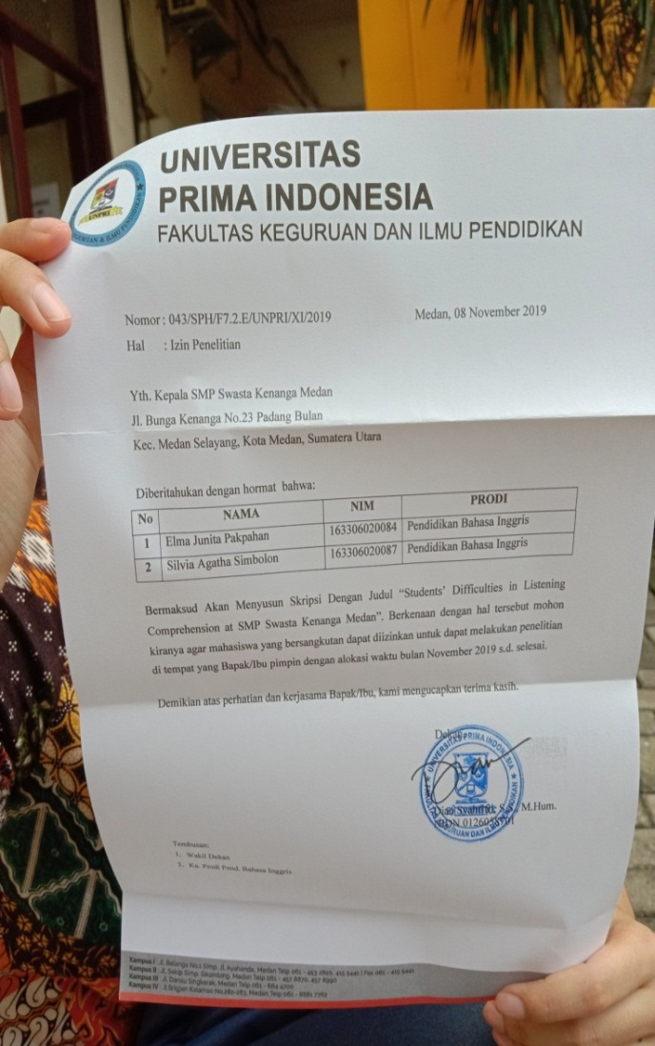

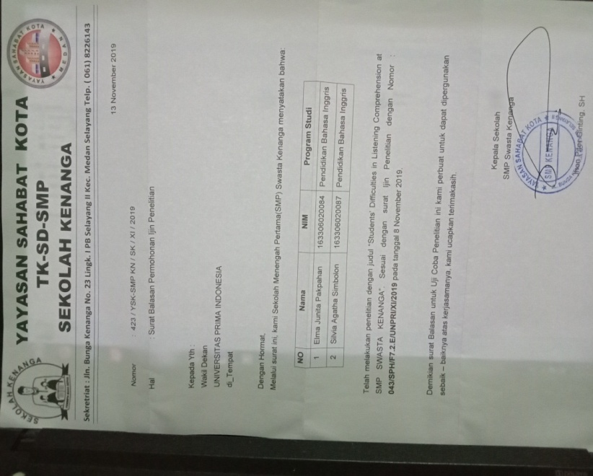

**APPENDIXES II : Listening Test, The Students’ Listening Test Score, The Questionnaire of Students’ Difficulties in Listening Comprehension, and The Transcript of Interview.**

**BEAUTIFUL IN WHITE**

**By : westlife**

Not sure if you know this, but when we first (1)……….

I got so nerveous, I couldn’t speak

In that very moment, I found the (2)……and,

My life had found its missing (3)……..

**Chorus**: so as long as i live i love you

Will have and hold you

You look so beautiful in white

And from now till my very last breath

This day i’ll cherish, you look so beautiful in white tonight...

What we have is (4)……., my love is endless

And with this (5)…….. i say to the world

You’re my every reason, you’re all that i (6)……. in

With all my heart i mean every (7)…….

**Back to chorus...**

And if a daughter’s what our (8)…….. holds

I hope she has your eyes

Finds love like you and i(9)……., yeah

But when she falls in love we’ll let her go

I’ll (10)…… her down the ailse

She’ll look so beautiful in white

You look so beautiful in white

**Back to chorus...**

**Answers :**

1. Met 6. Believe

2. one 7. Word

3. Piece 8. Future

4. Timeless 9. Did

5. Ring 10.Walk

**The Students’ Listening Test Score**

**Table 4.1**

|  |  |  |  |  |
| --- | --- | --- | --- | --- |
| **No** | **Students’ Initial Names** | **Correct** | **Incorrect** | **Score** |
| 1 | RJTP | 9 | 1 | 90 |
| 2 | ANS | 8 | 2 | 80 |
| 3 | GP | 8 | 2 | 80 |
| 4 | FS | 6 | 4 | 60 |
| 5 | SYN | 6 | 4 | 60 |
| 6 | RHS | 5 | 5 | 50 |
| 7 | TS | 5 | 5 | 50 |
| 8 | MK | 5 | 5 | 50 |
| 9 | BS | 5 | 5 | 50 |
| 10 | DS | 4 | 6 | 40 |
| 11 | RYS | 4 | 6 | 40 |
| 12 | PP | 4 | 6 | 40 |
| 13 | JRS | 3 | 7 | 30 |
| 14 | GW | 3 | 7 | 30 |
| **Total Mean** | | 75 | 65 | 750 |
| 5,3 | 4,6 | 53,6 |

**The Questionnaire of Students’ Difficulties in Listening Comprehension**

**Table 4.2**

|  |  |  |  |
| --- | --- | --- | --- |
| No | Questions | Answer (Yes) | Answer  (No) |
| 1 | Do you feel that learn to listening is difficult? | 7 | 7 |
| 2 | Do you have difficult to understanding unfamiliar vocabulary in listening comprehension? | 12 | 2 |
| 3 | Do you feel difficult to understanding every word spoken while listening? | 4 | 10 |
| 4 | When the conversation is too long, does interfere your listening comprehension? | 5 | 9 |
| 5 | Do you find any difficulties to interpret meaning of listening that too long? | 8 | 6 |
| 6 | Do you feel difficult to understand listening text when the topic is unfamiliar? | 11 | 3 |
| 7 | Do you feel difficult of listeng when the speaker talking too fast? | 12 | 2 |
| 8 | Do feel any difficulties to understand word reduced form in english? | 8 | 6 |
| 9 | Are the class situation/enviroment influenced or affect your concentration when learn listening? | 7 | 7 |
| 10 | Do you feel difficult to understand intonation that use by speaker? | 4 | 10 |

**The Transcript of Interview**

Researcher   : Did students at eight grade of Smp Swasta Kenanga experienced difficulties in listening comprehension?

English teacher : I think from the listening section before, just a few of them can understand, most of them feel difficult when listening.

Researcher  : How about the previous listening that they learn ?

English teacher :From the previous listening, because their listening is from english  book, and the speaker is not native speaker. So some of them can understand but there are also who feel difficult. If the topic of conversation in listening already explained by teacher before, usually they can guess the topic or what was they hear, but if they’re listening to a song or new conversation they’ll felt difficult because they didn’t know the topic, and in a song sometimes there were reduced form like, I will become i’ll. So its easier when they already learn the topic before.

Researcher    : How about unfamiliar word?

English teacher : that’s also an obstacle. There are some words that seldom they hear or never they hear, and at eight grade they seldom play song.

Researcher    : what is the appropriate solution?

English teacher : they must often listen western song, watching cartoon movie such as  “finding nemo “ because the prounciation is easy to understand.