KNOWLEDGE CONVERSION: AN EVALUATION OF BPPT KM APPLICATION UTILIZATION AS A KNOWLEDGE MANAGEMENT SYSTEM

Ria Ariani¹*, Nur Sanny Rahmawati²*
¹ Pusat Manajemen Informasi – Badan Pengkajian dan Penerapan Teknologi
²Universitas Indonesia

*Correspondence: arianiri@gmail.com; ria.ariani@bppt.go.id; nsannyrahmawati@gmail.com; nur.sanny@menpan.go.id;

ABSTRACT
This paper presents on how knowledge being converted through knowledge management application called BPPT KM App that is managed by Pusat Manajemen Informasi – Badan Pengkajian dan Penerapan Teknologi, and its function used as a knowledge management system. The purpose of this paper is to explain the implementation of knowledge conversion in Badan Pengkajian dan Penerapan Teknologi and to know how knowledge management system works and the effectivity from the app. The method used in this paper is qualitative with participative observation approach and narrative review. With these approaches, researchers do the direct investigation to the subject research and involved in the process of knowledge conversion of the app. The result of this study shows that knowledge conversion can be implemented by BPPT employees, whether the employees who located in MH Thamrin Jakarta or Puspiptek Serpong and the SECI indicators have been conducted in knowledge management system through the app. It can be concluded that BPPT KM App has facilitated knowledge conversion implementation to all BPPT employees remotely and it can be accessed anytime and anywhere, especially in this pandemic situation.

Keywords: Knowledge Conversion; Knowledge Management System; Agency for the Assessment and Application of Technology; Knowledge Management Application.
1. INTRODUCTION
Knowledge is an essential asset in an organization. Knowledge is everything that can be known, intelligence, or anything which is known that related to specific matter (Kamus Besar Bahasa Indonesia, 2007). Organizational knowledge may come from employee quality of thought that includes ideas focused on the organizational day-to-day activity (Polanyi, 1966). Knowledge processes were divided into two forms of knowledge that are tacit and explicit (Nonaka and Takeuchi, 1996; Huang and Wang, 2002). Tacit or implicit knowledge is knowledge that has been stored in individual minds but it is not explicitly expressed so that it cannot be understood by other individuals (Collins, 2010). Meanwhile, Kementerian Pendayagunaan Aparatur Negara dan Reformasi Birokrasi (2011) mentioned that explicit knowledge is all information represented in the organization and made it accessible to all organization members. This statement also supports to Polanyi (1966) that explicit knowledge should be rendered clear, explicitly stated and visible. Therefore, the process of knowledge conversion can be implemented in every organization.

Theoritically, knowledge conversion cannot be apart from knowledge management itself. It can be a model to analyze how knowledge management process works. Tseng (2010) describes the definition of knowledge conversion as a knowledge transformation process where tacit knowledge can be reformed to explicit knowledge and vice versa which contradicts to Polanyi (1966) statement “all knowledge is rooted in tacit knowledge”. The components of knowledge conversion are widely known as SECI (socialization, externalization, combination, dan internalization). Those four components can be utilized to know on how far knowledge has been managed in the organization.
Badan Pengkajian dan Penerapan Teknologi as an institution that works in the field of technology innovation and provides services based on technology, information and communication, needs to aware of organizational knowledge management in order to make a right decision for the organization. Knowledge that is managed in organization can be from employee’s ideas and experiences and it can be created through employee discussions. Consequently, Badan Pengkajian dan Penerapan Teknologi (BPPT) develops a system for managing some of the organizational knowledge which comes from the minds of employees and can be managed remotely such as finishing job tasks and brainstorming project ideas. This consideration certainly has enormous benefits in the process of managing organizational knowledge and all the knowledge conversion, especially in this pandemic situation where direct interaction is quite limited.

Several studies related to knowledge conversion and knowledge management system have been conducted both in Indonesia and internationally. One of them is a study that has been conducted by Ariq, Yani dan Sri (2020) who analyzed knowledge management system based on hydroponic aquaculture web with knowledge management cycle, in this study the process of knowledge conversion worked from tacit to explisit using a knowledge management system life cycle (KMSLC) method. Besides, Karto et. al. (2017) also discussed on a comparison between several results in the field of knowledge management system and the conclusion showed that the development of knowledge management systems in big data era or in the future must be balanced with the development of capabilities and its features. Additionally, in Sukmawati, et. al. (2010) knowledge conversion is more emphasized on knowledge usage process, both tacit and explicit, as a strategy to encourage business innovation in a dairy small enterprise.
Looking at these backgrounds, the authors aim to explain the conduct of knowledge conversion in Badan Pengkajian dan Penerapan Teknologi (BPPT) and to know the effectivity of the knowledge management system from BPPT knowledge management application. The expected aim of this paper is to provide an extensive overview of the knowledge conversion that occurs in Badan Pengkajian dan Penerapan Teknologi (BPPT). In addition, this research is hoped to provide an overview of the connection between employee activities and knowledge conversion in the knowledge management application with SECI indicators.

2. LITERATURE REVIEW
2.1 Knowledge Conversion

Knowledge conversion is a branch of knowledge management. It has been known through a number of literatures that knowledge management is a management process related to people with their uniqueness, expertises and experiences (Nonaka dalam Yusup, 2012). Tjakraatmadja (2006) also added that knowledge management is influenced by a good working culture whether vertical or horizontal (among coworkers). Then, knowledge management can be sistematical steps on how knowedge is organized starting with sharing experiences and discussion results in an organization.
At the beginning, the concept of knowledge conversion was stated by Nonaka and Takeuchi (1995). Furthermore, knowledge conversion used as analysis model that combines both tacit and explicit knowledge. There is a well-known knowledge conversion model namely SECI and it stands for socialization, externalization, combination, and internalization (Nonaka dan Takeuchi in Gourlay, 2003), with steps as follow:
- First stage - Socialization
Socialization is a knowledge conversion process where tacit knowledge (knowledge that is in individual minds) reformed to tacit knowledge as well but in a more advance way (Priambada, 2010).
- Second Stage- Externalization
Externalization is a knowledge conversion process where tacit knowledge changeed into explicit knowledge (Priambada, 2010).
- Third Stage - Combination
Combination is a continuation of externalization process where explicit knowledge (knowledge that has been documented) converted to explicit knowledge (Priambada, 2010).
- Fourth Stage - Internalization
Internalization is a knowledge conversion process where the new explicit knowledge can be a tacit knowledge for individuals who receive it (Priambada, 2010).

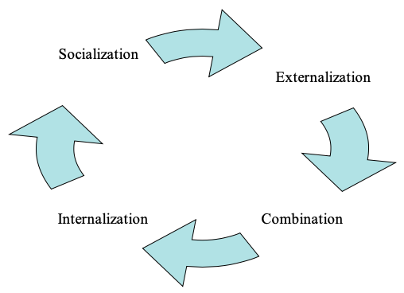

Figure 1. Knowledge Conversion: SECI Model

2.2 Knowledge Management System
Knowledge management system (KMS) is a collection of strategies and practices to analyze, to organize, to distribute, to maintain and to share knowledge from the experiences of organization (Alavi, 2001). Additionally, Ahlawat (in Subagdja, 2011) defined knowledge management system as a modern information technology utilization for systemization in the purpose to increase and to accelerate knowledge management within organization. King dan Marks Jr. (2008) also mentioned that knowledge management system is intended to support knowledge sharing in an organization so that knowledge dissemination can be delivered to a wider audience.
There are the main objectives of KMS (Davenport et. al. dalam Fahmi, 2013), as follows:
- Creating Knowledge
Knowledge was created when people doing specific activity. External knowledge sometimes being brought to the organization by people who are working on it.

- Capturing Knowledge
Knowledge was identified and represented as a logical value in a logical way.

- Collaborating Knowledge
New knowledge can be placed in a context where it can be continued with another knowledge.

- Storing knowledge
Useful knowledge can be stored so that other individuals in the organization can access it when the need it.

- Processing knowledge
Knowledge should be kept updated along with its relevancy and accuracy.

- Disseminating knowledge
Knowledge should be disseminated and available in a proper format then it can be accessed anytime and anywhere by employees in an organization.

2.3 10-Step Knowledge Management Roadmap

In a knowledge conversion process, specifically to the knowledge management system part, it can be quite complicated. Thus, all the stages in knowledge conversion, which is part of knowledge management system, needs to be known started by knowledge planning until its evaluation. 10-Step Knowledge Management Roadmap is giving a clear direction and can be utilized to analyze a knowledge management system. This theory stated by Amrit Tiwana (1999). Amrit described phases of 10-Step Knowledge Management Roadmap as the main activities follow:
- Infrastructure evaluation
This phase covers the activity of analyzing the infrastructure and cooperate it with business processes and knowledge management processes.

- System analysis, design and system development
At this second phase, Knowledge management infrastructure is designed, all assets and systems are audited and knowledge management system is developed.

- Deployment system
The third phase consists of deploying activity with a method of result-driven incremental where change, culture, and reward structure are managed.

- Evaluation
This last phase, system performance is evaluated and return of investment (ROI) is measured.
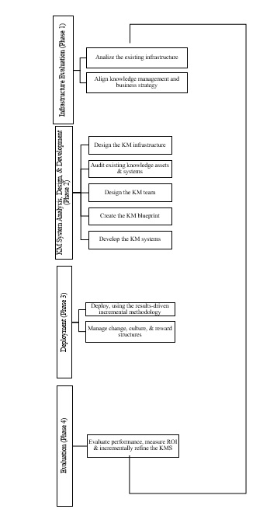

Figure 2. 10-Step KM Roadmap

3. METHOD
This study uses a qualitative method with participatory observation approach and narrative review. A qualitative research concerns on the facts that can be put dan can be seen by a person, whether as a researcher or an object of research – a subjective construction (Pendit in Rahmawati, 2016). Participatory observation approach is an approach where researcher is involved in the activities of research object which investigated and it is used as sources of research (Sugiyono, 2017). In participatory observation, a researcher sees what is done related to the reserch object, hears what peple say and involved in the conduct of what people do (Susan Stainback in Sugiyono, 2017). In addition, Middleton (2012) stated that narrative review is needed to gain comprehensive understanding related to research topic, ini this case they are knowledge management system, knowledge conversion, knowledge management, and effectivity of knowledge management system usage in the organization. Analysis technique used is descriptive content analysis. This technique is considered suitable with the research topic because it describes research content which is investigated by analyzing knowledge management system phenomenon utilized in BPPT using related literatures (Vaismoradi, Turunen, dan Bondas, 2013). Also, narrative review is conducted with the literatures in the topic of knowledge conversion and knowledge management system so that theoretical foundation can be built to support the research topic.

4. RESULTS AND DISCUSSION
4.1 Content Analysis BPPT KM App
Application of Knowledge Management (KM) BPPT is a tool for managing BPPT intellectual assets to give an easiness to employees in order to acquire knowledge, share knowledge, discuss and collaborate among other employees, also to encourage and to improve innovation of technology in organization, and to assist BPPT stakeholders in the process of decision making so it can be done effectively and efficiently. The concept of this app came from BPPT Chairman himself to monitor and to track down all the projects and the work results of all BPPT employees in a top to down-level hierarchy. For example, staff can be monitored by head of subdivision, then head of the working unit can also monitor all head of divisions and sub-divisions under him. Additionally, using this app BPPT Chairman can monitor the work that is taking place and can give a direct instruction to the required employee.

This BPPT KM Application was built with the objectives of ensuring the effectivity BPPT knowledge management processes both tacit and explicit to create a supportive environment as a learning organization so that each employee being able to adapt to environmental changes quickly and can encourage the creation of competitive technological innovations by benefitiing all functionality and data that is made available in the app. All knowledge that has been store in BPPT KM Application can be accessed using the address https://km.bppt.go.id. Additionally, BPPT KM App can be accessed through mobile phone by downloading the application first, whether in Playstore for Android and Appstore for iPhone. Each knowledge conversion described in the SECI model hoped to be implemented and applied in BPPT KM application and it is provided through all features available in the BPPT KM application. All knowledge management system (KMS) processes at BPPT can be illustrated in Figure 3 below:

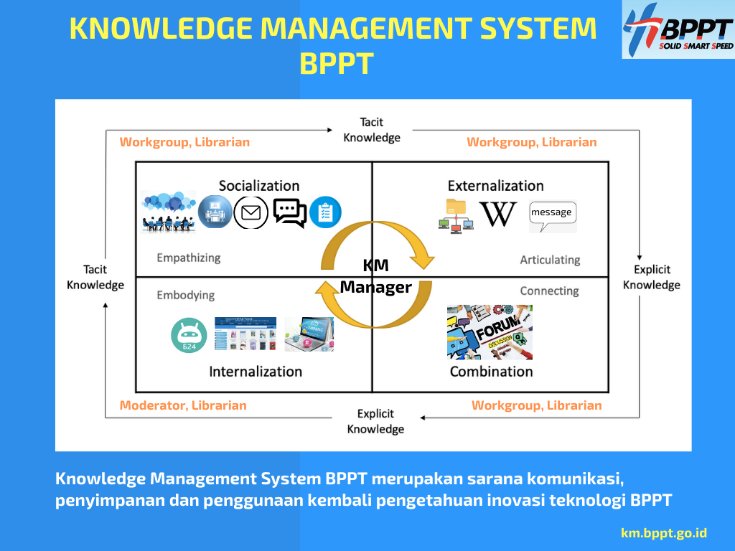
Figure 3. SECI flow in BPPT Knowledge Management System

The features in the app was created to support the implementation of knowledge management and knowledge conversion at BPPT. They are as follows:
- Task Feature
The Task feature is a feature in the KM BPPT application where the purpose is to manage all employee tasks in their daily activities and the project activities can be observed directly by their supervisors at BPPT. The display of Task Feature can be seen at Figure 4.

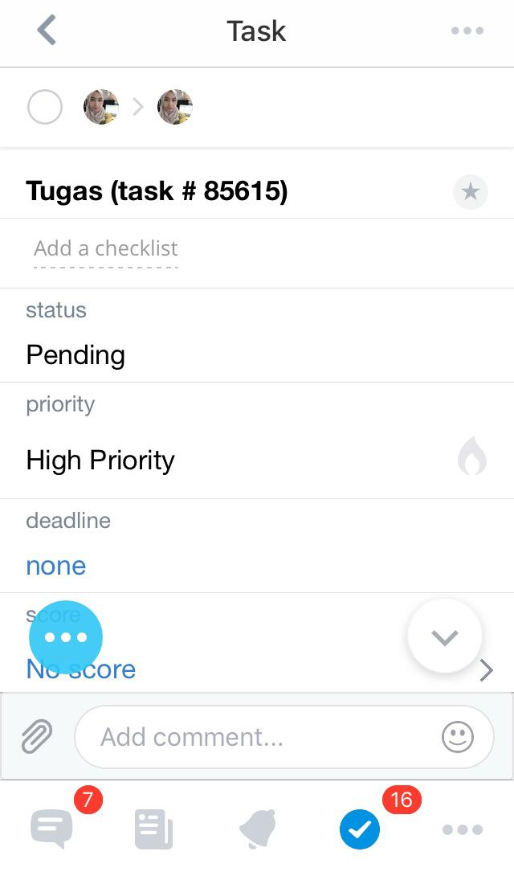
Figure 4. Task Feature at BPPT KM Application

In this feature, a supervisor at BPPT in the level of eselon 1, eselon 2, eselon 3 and eselon 4 can delegate a task to the employees under their division to be completed, Then, all notification of the tasks will automatically appear at the BPPT KM application on the mobile phone and employees who receive the assignments can be directly start the tasks that have been assigned. Supervisors can also monitor the process of the task conduction whether if it has been finished or not.

- Clock-in and Clock-out Feature
The Clock-in and Clock-out feature in t BPPT KM application is a tool made to replace the manual presence system in BPPT, and BPPT employee attendance is directly recorded in the application. Then, it is counted as working day duration. This feature was developed to create a function of working time management where employees can present their attendances when they arrive at office dan when they are going to leave. Figure 5 and Figure 6 show the interface of Clock-in and Clock-out feature in BPPT KM application.

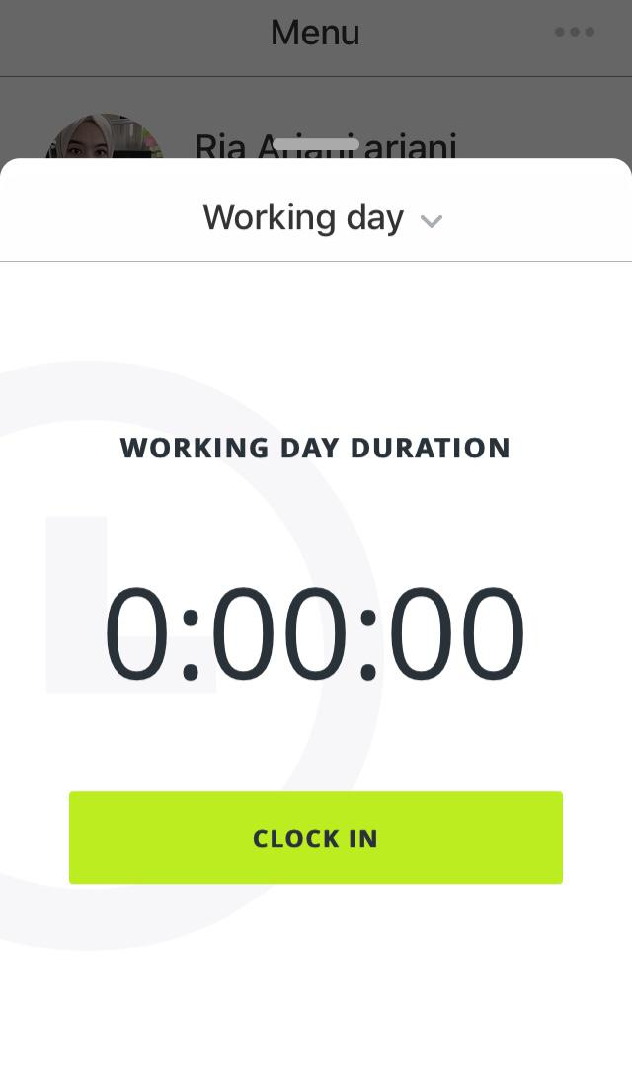

Figure 5. Clock-in feature at BPPT KM Application


Figure 6. Clock-out feature at BPPT KM Application

- Activity Stream Feature
As its name, this feature shows all activities and tasks that happen at BPPT KM application just like ‘news feeds’ in Facebook. From this menu, all employees can directly interact, collaborate and share data with other employees. For instance, the display for this feature can be seen in Figure 7.

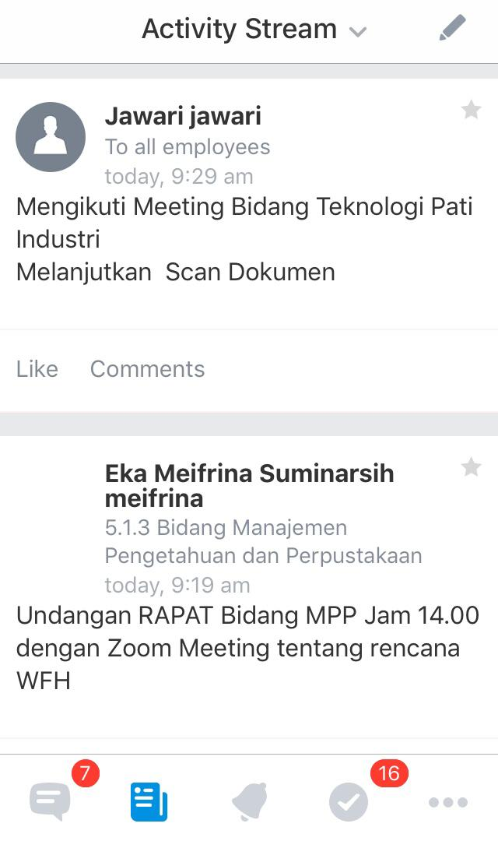
Figure 7. Activity Stream Feature at BPPT KM Application

- Calendar
In the application, Calendar feature is utilized as an agenda where the employees can set a schedule of daily activities or meetings, and it can include other employees and working units in BPPT. At this feature, a number of participants who are involved in the activity can be arranged and a reminder can be made to remind all the participants regarding the agenda or the activity. The example of calender feature can be seen at Figure 8.

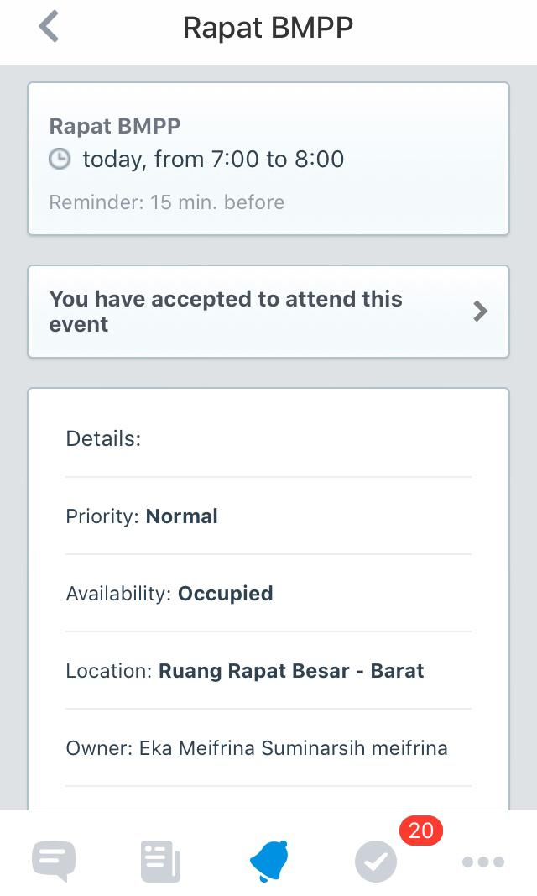
Figure 8. Calendar feature at BPPT KM application

- Drive
Drive feature at BPPT KM apllication functioned as a storage or a container for managing all documents or files which are available at BPPT KM application. In this feature, files and documents can be saved, communal edited and shared via internal links or shared publicly. Drive feature was created as a file storage for storing all employee files and documentations. The display of drive feature is shown in Figure 9.

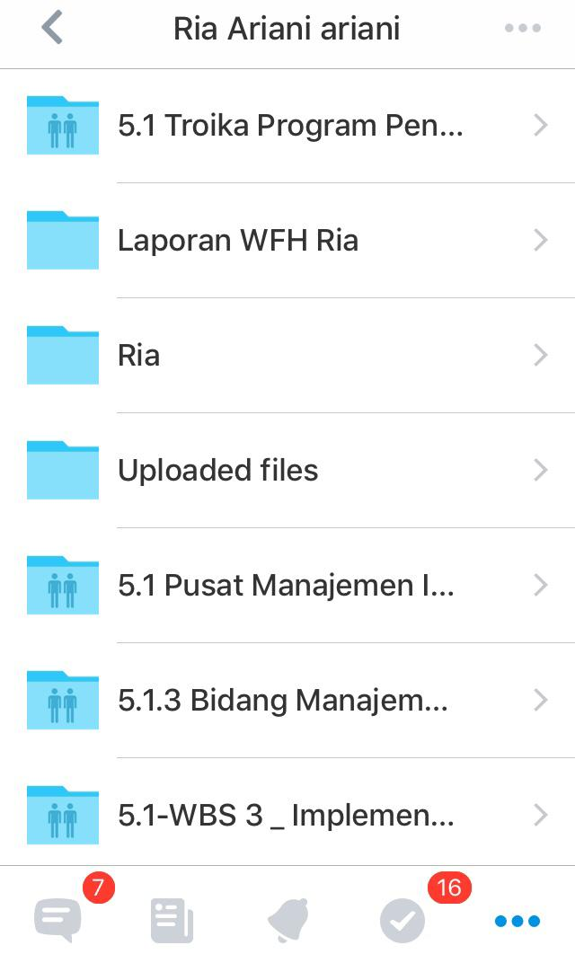
Figure 9. Drive feature at BPPT KM Application

- Chats
This feature is a tool provided in the application for BPPT employees to communicate and discuss with other employees. It can be done by chatting or video call to other employess in BPPT. In this feature, a video call can be done with maximum of four users. Examples of chat feature display can be seen in Figure 10.

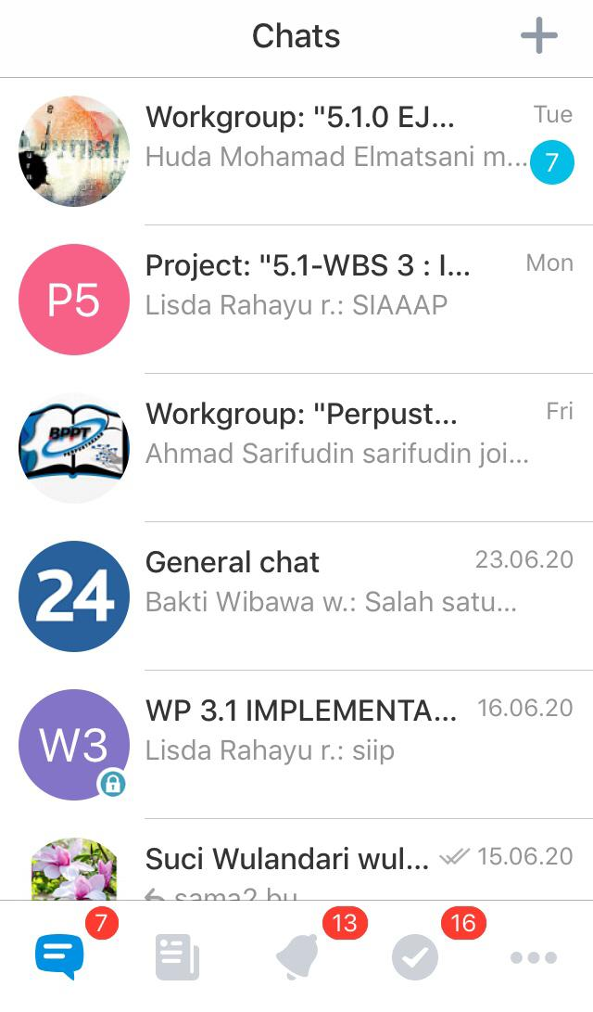
Figure 10. Chats feature at BPPT KM application

- Notifications
In BPPT KM application, there is also a notifications feature, where each employee will be able to know if there is any task given by supervisors or if there is any invitation of meetings or activities and the notifications will appear on BPPT employee's mobile phone right away through the BPPT KM Application. Figure 11 shows the display of notifications feature at BPPT KM application.

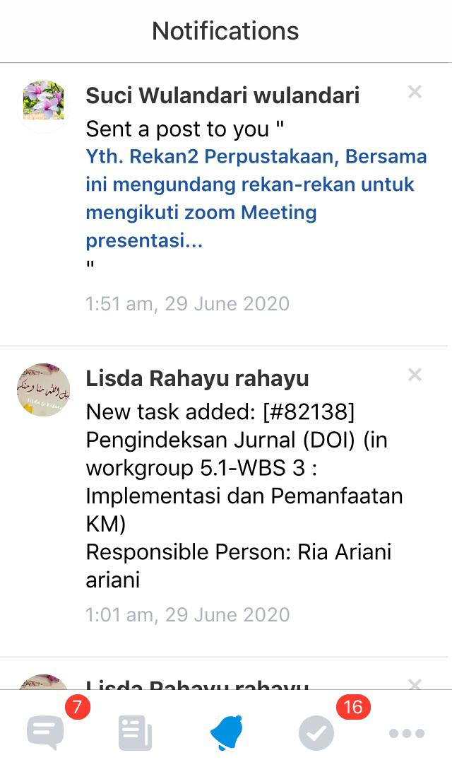
Figure 11. Notifications feature at BPPT KM Application

Furthermore, through its features, BPPT KM application is expected to make everything easier for all BPPT employees in order to manage their knowledge. As it is explained in Fitriasmi (2010) that if the the system is getting better then there is no doubt that more people will use it. In the context of BPPT KM Application, based on the theory stated by Fitriasmi (2010) there is a positive correlation between the BPPT KM Application and the output where BPPT intellectual assets being managed in this KM application. Supported by a good quality system, BPPT KM application is hoped to be able to solve the needs of the organization and can solve institutional problems.

4.2 Evaluation and Knowledge Conversion in BPPT KM Application

- Knowledge evaluation in BPPT KM Application

BPPT KM Application that used as a knowledge management system (KMS) in Badan Pengkajian dan Penerapan Teknologi (BPPT) is a mobile-based application developed to support document management and engineering activities which are conducted at BPPT, which supplemented with file sharing then all employees can exchange files, documents and data. Utilization of knowledge management system through BPPT KM application has been running since the beginning of 2020 and has been socialized to more than 20 (twenty) technical working units in BPPT.

At the beginning, BPPT Knowledge Management (KM) application was originated from the idea of developing the old system of BPPT knowledge management portal which can be accessed via the address https://kms.bppt.go.id page. The concept of the old BPPT knowledge management system portal is actually a combination of several services managed by Bidang Manajemen Pengetahuan dan Perpustakaan–Pusat Manajemen Informasi BPPT, which include: Digital Library BPPT (digilib.bppt.go.id), Expertise System BPPT, BPPT Press and BPPT Electronic Journal (ejurnal.bppt.go.id). However, this portal is considered lack of interactivity with BPPT employees, so the development of the second BPPT knowledge management system was initiated and it can be accessed from km.bppt.go.id portal, which includes BPPT KM Application.

Actually, BPPT KM Application is not made by BPPT and uses an outsourcing service from Bitrix24. The type of platform used is for communication, collaboration and management of company assets. Facilities given from BPPT KM application features can also be connected with another platform such as Googledocs, for example in the use of editing collaboration. To activate this application it should be connected to BPPT employee intranet username and password using the LDAP (Lightweight Directory Access Protocol) protocol. After that, the BPPT KM Application can be utilized during the internet network both inside and outside the BPPT environment. In terms of security, BPPT KM application server has also been moved to BPPT then it has been secured. The application itself can be downloaded via the Appstore and Playstore for mobile use.

If we see from the perspective of business process, BPPT KM Application is expected to provide an easiness in finding, sharing, discussing and collaborating amongst BPPT employees so that it can improve technological innovation in the institution, and it can assist BPPT leaders in decision making appropriately and quickly by utilizing the menus available in the application. However, aside its development, there are still identified some limitations in using BPPT KM application as shown in Table 1 below.

Business Process | Strength | Weakness
- Login to App | Secure (using internal username and password) | Closed access (data could not be seen by external party)
- Selecting the features | Variety of features to support work management | Running only under internet connection
- Adding the files | Easy navigation | Many optional tools, users need the guideline on how to do it
- Adding the participants in the features | Easy selection | Could not involve external user
- Activities notifications | Pop up notifications in the mobile | Each activity will be notified (alert abundance)
Table 1. Business processes and limitations

Table 1 above illustrates that there are number of weaknesses and strengths have been identified in the use of BPPT KM application. As it is described in the table, each business process analyzes its strenght and weakness so users can manage all knowledge in this system properly. The advantageous aspect in the application include: 1) Secure system because only BPPT employees who have internal username and password/access to use this application, 2) Easiness of managing files, 3) User friendly navigation and 4) Notifications that will pop up in users’ mobile phone. However, there are also limitations in using this application, such as : 1) Data cannot be exposed to public, 2) Abundance of options and menus in this application, 3) External users cannot be involved, and 4) There will be a load of notifications because each activity in BPPT KM application will appear.

- Knowledge Conversion in BPPT KM Application
The main elements of BPPT KM Application are document management, chat and community of practice. The early reason of implementing KM Application in BPPT is to make it better in identifying which knowledge that should be treated by BPPT working units and to identify the specific expertise that belongs to specific individual in BPPT. Zhou and Fink (2017) mentioned that it is vital for an organization to encourage and develop the knowledge of its employees or its members. Conversely, organizations also need to create an environment that encourages an active sharing knowledge culture and it can monitor the management of knowledge that happens in a system, specifically knowledge management system.

If we look at the above definition, BPPT as an institution has made some efforts in the process of managing knowledge by implementing a knowledge management system called BPPT KM Application. By looking at its features, it can be concluded that knowledge conversion has worked in the app and we can look on each feature in KM app that represents the SECI Model, as follows:

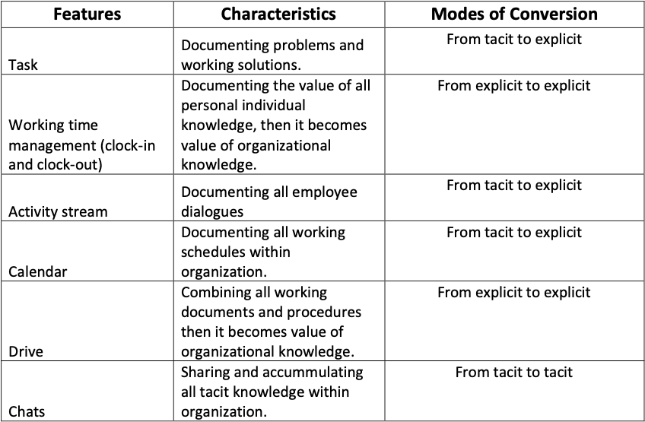
Tabel 2. Categorization of KM App Features in SECI Model

Based on Table 2, it can be said that the features in BPPT KM application encourage and facilitate the occurrence of knowledge conversion as it was described by Nonaka and Takeuchi (in Gourlay, 2003) and it supports the SECI theory which includes socialization, externalization, combination, and internalization. From all seven features in application, six features represent at least one of knowledge conversion aspects in SECI. The six features that reflect to knowledge conversion activities are task features, working time management (clock-in and clock-out), activity stream, calendar, drive and chats.

Socialization aspect can be supported by chat feature where ideas which are coming from BPPT employees can be used by other employees and it can be a new idea that will help them in conducting their work and encourage the creation of innovation in their working place. Andrawina (2012) defined the socialization as transfer knowledge processing from tacit to tacit. One of the characteristics she stated that knowledge keeps strolling around within the organization as in the feature Chats all employees tacit knowledge are available in the app where it can stimulate other ideas.

The second coversion form of SECI is externalization. It can be found in the feature of tasks, activity stream and calendar. According to Nugraha (2015) that it is a documentation process that shaped tacit knowledge in the form of a document, so that others can see, read and learn from it. All work tasks were given to the needed employees in the feature tasks, then the proof of the work is submitted to the app so that the supervisor can directly evaluate and read it. It can be said that tasks feature has represented the element of externalization. The same characteristic also can be seen in feature activity stream and calendar, where employees dialogues and schedules are documented in the app so others can see and evaluate it.
Feature drive represents the stage of combination where the mode of knowledge conversion from explicit to explicit knowledge. In this aspect, all working documentation and procedures are combined together and it brings the value for organization, specifically BPPT. Andrawina (2012) stated that combining individual knowledge is important in the combination stage and it can be used as organizational best practice and stakeholders can also analyze which best practices offer the best organizational knowledge.

Zhou and Fink (2017) also stated that a knowledge management system that supported by the advanced technology can be a way for increasing the value and competitiveness of organizations. They emphasized in their paper that good knowledge management framework is the one that could lead organizations in creating a systematic work system.

5. CONCLUSION
Overall, from the observation activities which has been conducted it is known that BPPT KM Application is reliable and it has brought a number of benefits to employees to support their work activities. It can also be concluded that knowledge conversion in BPPT knowledge management system has been implemented appropriately in the aspects of SECI theory from Nonaka and Takeuci (1996). The features contained in KM application that can support the conduct of knowledge management in stages of SECI model are task, working time management (clock-in and clock-out), activity stream, calendar, drive and chats
All features and business processes in BPPT KM application also support the implementation of knowledge conversion that is represented in the system. Furthermore, for future research recommendation, it is important to know how institutional regulations play a role in the implementation of knowledge management system application in BPPT so a more comprehensive and in-depth understanding related to knowledge management aspects can be provided.

BIBLIOGRAPHY
Alavi M, dan Leidner DE. (2001). Knowledge Management and Knowledge Systems: Conceptual Foundations and Research Issue. MIS Quarterly, Vol. 25(1), pp. 107-136.
Ariq, Cahya Wardhana, Yani Nurhadryani, dan Sri Wahyuni. (2020). Knowledge Management System Berbasis Web tentang Budidaya Hidroponik untuk Mendukung Smart Society. Jurnal Teknologi Informasi dan Ilmu Komputer (JTIIK), Vol. 7(3), Pp. 619-628. Diakses Melalui http://jtiik.ub.ac.id/index.php/jtiik/article/view/2200/pdf pada 17 Juni 2020.
Collins, Harry. (2010). Tacit and Explicit Knowledge. Chicago: The University of Chicago Press.
Fahmi, Alusi. (2013). Kajian Pengembangan Knowledge Management System (KMS) untuk Litbang Kedirgantaraan pada Lembaga Penerbangan dan Antariksa Nasional (LAPAN). Berita Dirgantara, Vol. 14(1), pp. 17-24. Diakses melalui http://jurnal.lapan.go.id/index.php/berita_dirgantara/article/view/2061 pada 18 Juni 2020.
Fitriasmi, Sebtina Mulya. (2010). Evaluasi Kesuksesan Aplikasi Knowledge Management dalam Organisasi. Jurnal Dinamika Manajemen, 1 ( 1), pp. 18-26, https://journal.unnes.ac.id/nju/index.php/jdm/article/view/2444
Gourlay, S. (2003). The SECI Model of Knowledge Craetion: Some Empirical Shortcomings. Diakses melalui http://eprints.kingston.ac.uk/2291/1/gourlay%202004%20seci.pdf , pada 18 Juni 2020.
Indonesia. (2011). Peraturan Menteri PANRB Nomor 14 tahun 2011 tentang Pedoman Pelaksanaan Program Manajemen Pengetahuan (Knowledge Management). Jakarta: Kementerian PANRB.
Kamus Besar Bahasa Indonesia. (2007). Jakarta: Balai Pustaka.
Karto, Iskandar, Muhammad Ikhwan Jambak, Raymondus Kosala, dan Harjanto Prabowo. (2017). Current Issue on Knowledge Management System for Future Research: A Systematic Literature Review. International Conference on Computer Science and Computational Intelligence (ICCSCI 2017). Diakses melalui https://www.researchgate.net/publication/320396848_Current_Issue_on_Knowledge_Management_System_for_future_research_a_Systematic_Literature_Review pada 16 Juni 2020
King, William R. and Mark Jr., Peter. (2008). Motivating knowledge sharing through a knowledge management system. Omega, 2008, 36 (1), February 2008, pp. 131-146, https://doi.org/10.1016/j.omega.2005.10.006
Nonaka, Ikujiro dan Hirotaka Takeuchi. (1995). The Knowledge-Creating Company: How Japanese Companies Create the Dynamic of Innovation. New York: Oxford University Press.
Nonaka, Ikujiro dan Toshiro Nishiguchi. (2001). Knowledge Emergence: Social, Technical, and Evolutionary Dimensions of Knowledge Creation. New York: Oxford University Press.
Middleton, Paul M. (2012). Practical use of the Glasgow Coma Scale; a comprehensive narrative review of GCS methodology. Australasian Emergency Nursing Journal, 15 (3), pp. 170-183, https://doi.org/10.1016/j.aenj.2012.06.002
Priambada, Dewa Boy. (2010). Implementasi Knowledge Management System di Perusahaan. Bogor: Institut Pertanian Bogor. Diakses dari https://www.scribd.com/doc/28192137/Implementasi-Knowledge-Management-System-di-Perusahaan
Rahmawati, Nur Sanny. (2016). Berbagi Pengetahuan: Representasi dalam Novel Paper Heart. Depok: Universitas Indonesia.
Subagja, Sambas. (2011). Perancangan Knowledge Manajement System Untuk Pelaanan Perizinan Terpadu Satu Pintu. Konferensi Teknologi Informasi dan Komunikasi untuk Indonesia. 14-15 Juni 2011. Bandung
Sugiyono. (2017). Metode Penelitian Kuantitatif, Kualitatif, dan R&D. Bandung : Alfabeta.
Sukmawati, A., M.S. Ma’arif, Marimin, H. Hardjomidjojo, dan N.S. Indrasti. (2010). Model Kontribusi Aset Pengetahuan dalam Memfasilitasi Proses Penciptaan Pengetahuan pada Koperasi Susu. Jurnal Manajemen dan Organisasi, Vol. 1(1). Diakses melalui http://journal.ipb.ac.id/index.php/jmo/article/download/14150/10544 pada 15 Juni 2020.
Tiwana, Amrit. (1999). The Knowledge Management Toolkid: Practical Technique for Building a Knowledge Management System. London: Prentice-Hall, Inc.
Tjakraatmadja, Jann Hidajat dan Donald Crestofel Lantu. (2006). Knowledge Management dalam Konteks Organisasi Pembelajar. Bandung: SBM-ITB.
Tseng, S. (2010). The correlation between organizational culture and knowledge conversion on corporate performance. Journal of Knowledge Management, Vol. 14 No. 2, pp. 269-284. https://doi.org/10.1108/13673271011032409
Vaismoradi, M., Turunen, H. and Bondas, T. (2013), Qualitative descriptive study. Nurs Health Sci, 15, pp. 398-405, doi:10.1111/nhs.12048
Venkatraman, S. and Venkatraman, R. (2018). Communities of Practice Approach for Knowledge Management Systems. Systems, 6(4), 36, https://doi.org/10.3390/systems6040036
Yusup M., Pawit. (2012). Perspektif Manajemen Pengetahuan Informasi, Komunikasi, Pendidikan, dan Perpustakaan. Jakarta: Rajawali Pers.
Zhou, Albert Z and Fink, Dieter. (2003). Knowledge management and intellectual capital: an empirical examination of current practice in Australia, Knowledge Management Research & Practice, 1:2, 86-94, DOI: 10.1057/palgrave.kmrp.8500009

