**THE DEVELOPMENT OF PROFESSIONAL PDF FLIP-BASED LEARNING MEDIA IN THEMATIC LEARNING AT THE THIRD GRADE OF ELEMENTARY**

**SCHOOL/ ISLAMIC ELEMENTARY SCHOOL**

**Siti Fatonah1, Teguh Yunianto2**

1,2 State Islamic University Sunan Kalijaga Yogyakarta

1,2 Jl. Marsda Adisucipto, Yogyakarta 55281

Email: [sitifat317@gmail.com1](mailto:sitifat317@gmail.com1), [teguhyunianto96@gmail.com](mailto:teguhyunianto96@gmail.com) 2

WA Number of the 1st Author: 0856 8537 712

**Abstract**

Pembelajaran tematik menuntut adanya kreatifitas pendidik dalam memilih dan mengembangkan tema pembelajaran salah satunya denga menggunakan media pembelajaran flip pdf profesional. Penelitian ini bertujuan untuk mengetahui kelayakan, respon pendidik dan respon pesrta didik terhadap media pembelajaran berbasis flip pdf profesional pda pembelajaran tematik. Penelitian ini merupakan penelitian pengembangan jenis model Borg and Gall yang telah dimodifikasi. Hasil penelitian menunjukkan penilaian ahli media 94,54% dengan kategori sangat layak, ahli materi 86,66% dengan kategori sangat layak dan ahli bahasa 94,54% dengan kategori sangat layak. Selain itu, respon pendidik diperoleh nilai rara-rata 95% dengan kategori sangat layak, uji coba skala kecil diperoleh nilai rata-rata sebesar 91,3% dengan kriteria interprestasi sangat menarik dan uji coba skala besar diperoleh nilai sebsar 95,8% dengan kriteria interprestasi sangat menarik. Sehingga media pembelajaran berbasis flip pdf profesional sangat layak dan sangat menarik digunakan sebagai media pembelajaran tematik.

**Abstract**

Thematic learning requires the creativity of teachers in selecting and developing learning themes, one of them is by using professional flip pdf learning media. This study aims to determine the feasibility, the response of teachers and students towards professional flip pdf based learning media for thematic learning. This research is a development research of modified Borg and Gall model. The results showed that the media expert's assessment was 94.54% in the very feasible category, 86.66% of the material experts was in the very feasible category, and 94.54% of the linguists with the very feasible category. In addition, the teacher's response was obtained the average of 95% with the very feasible category, small-scale trials was obtained the average of 91.3% with very interesting interpretation criteria and large-scale trials was obtained a value of 95.8% with very attractive interpretation criteria. Therefore, professional pdf flip-based learning media are very feasible and very interesting to be used as thematic learning media.

**Keywords**

thematic learning, flip professional pdf, learning media

**INTRODUCTION**

Education is one of the most important parts of human development to increase the quality of resources in supporting life in the future (Yuliati Zakiyah 2014). To encounter this challenge, an effective learning process and also learning media can be serve as facilities to achieve the required learning purpose (Sholichah 2018). By the implementation of education, it is hoped that it can overcome the social problems that occur in the community, the efforts of education are noticed by the government through the implemented curriculum (Chairul 2017).

The curriculum is a set of plans and arrangements regarding to the objectives, content and learning materials and methods that are used as guidelines in implementing the students’ learning activities to achieve the certain educational goals (Widyastono 2014). The purpose of curriculum is to encourage the students to be better in observing, asking, reasoning, and representing what they have gained after receiving the learning material at school (Rufiana 2016). The current curriculum used is the curriculum 2013, the curriculum 2013 is a curriculum with competency-based which includes attitude competence, knowledge, and skills. To achieve the formulated competencies, the thematic learning is chosen as the basis for learning (Suyatmini 2017).

Thematic learning as the learning system that allows students both individually or as a group to actively explore and find concepts and principles holistically, meaningfully and authentically (Narti et al. 2015). Thematic learning is a learning concept that involves several subjects to provide the meaningful experiences for students (Setiawan, Fajaruddin, and Andini 2019). Thematic learning is demanding the teachers’ creativity in choosing and developing the learning themes. Thematic learning in the curriculum 2013 is expects that teachers can teach or at least show the students how technology is in learning process such as using interactive learning media based on applications (Hidayah 2015).

Learning media is a tool to improve the activities in teaching and learning process so that there is a willingness to be more enthusiastic in following a learning process (Rahmi, Budiman, and Widyaningrum 2019). The creativity in using learning media can facilitate and increase the efficiency of learning so that learning objectives can be achieved (Ramli 2015). The advantages of learning media as a teaching method will be more varied, not only verbal communication from the teacher. Therefore, students do not feel bored, the learning will attract the students' attention so that it can encourage their learning motivation, learning material will be easier to be understood by the students (Arda , Saehana, and Darsikin 2015). The function of learning media is to grow and encourage the students’ regular and continuous thinking especially through live images, enlarge the students’ attention, help the development of students’ language skills, and also provide real experiences that can stimulate the students’ thinking. (Arsyad 2016).

The fact is showing that teachers are rarely using practical, innovative, and varied learning media or another learning that are interested for the students. Lack of learning media use in thematic learning during the learning activities is only focusing on theme books and teaching tool and there are still lack of the ability in developing technology-based media.

Based on those facts, it is necessary to have learning media through the new and interactive software form. One of them is professional flip pdf. Professional flip pdf is an E-book maker software in the form of flip book (Watin 2017). Professional flip pdf has the advantages of being able to input videos in a PDF and also it does not require an internet connection (Yunianto, Negara, and Suherman 2019).

The previous research showed that the use of e-modules with a scientific approach by using professional flip pdf on square and rectangular materials are very effective to use in the mathematics learning process, and also this research provides a feasibility and valid results (Agustin and Pratama 2020). In addition, 3D page flip development research provides the valid results, so that it can be used in the science learning process of electrolyte and non-electrolyte solutions (Utami 2017). Moreover, there is RPS Flip builder development research that is aimed to improve students’ understanding in science learning during the Covid-19 period. The result of this research said that flip builder learning media on science (IPA) material is feasible and very practical to be used (Yunianto 2021).

This research has a novelty that is the thematic learning with the theme “loving plants and animals” by using professional flip pdf. This research is expected to be a solution to teachers for being able to provide learning innovations. This study was aimed to determine the feasibility and response of teachers and students to learning media based on professional flip pdf.

**RESEARCH METHOD**

This type of research and development used a modified Borg and Gall model (Sugiyono 2017). The steps can be seen in picture 1:

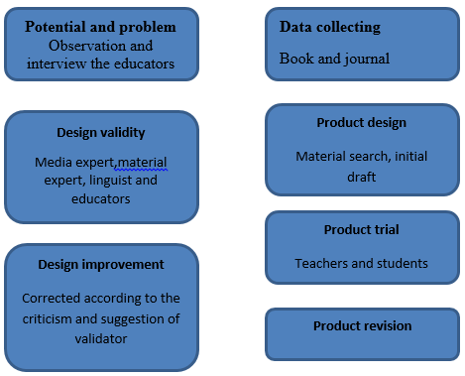

Picture 1: research design

The data collection in this study was gathered by using observation, questionnaire and documentation (W Creswell 2019). Technique of data analysis in this research was feasibility questionnaire. The analysis results used expert validation sheets, teachers’ response sheets, and data questionnaire used is Likert scale form (Putra 2015). The instrument has 5 answers that can be described in table 1:

Table 1

Original validity of assessment scale

|  |  |
| --- | --- |
| **Answer choices**  Excellent  Good  Average  Poor  Very poor | **Score**  5  4  3  2  1 |

The total assessment score can be calculated by using the following formula (Latifa 2016):

P = $\frac{f}{N}$ x 100%

Note:

F= Obtained Scor

N= Total Frequency/ Maximum Score

P= Percentage Number

The average score of each expert validation is to determine the validity and feasibility of learning media.

Table 2

Criteria of Validity

| **No** | **Percentage (%)** | **Assessment Criteria** |
| --- | --- | --- |
| 1 | 0 – 50 | Very Inappropriate |
| 2 | 50 – 60 | Not Feasible |
| 3 | 60 – 70 | Less Feasible |
| 4 | 70 – 80 | Feasible |
| 5 | 80 – 100 | Very Feasible |

According to the questionnaire, the responses of teachers and students about the use of this product have 5 choice of answer. Each answer has different score which indicates the level of product compatibility for the user. The score of each answer can be seen in table 3.

Tabel 3

The Assessment Score of Each Answer

| **Category** | **Score** |
| --- | --- |
| Strongly agree | 5 |
| Agree | 4 |
| Neutral | 3 |
| Disagree | 2 |
| Strongly disagree | 1 |

The results of assessment scores from each teachers and students are used to find the average, and then converted them to the questions form to know the criteria of teachers and students’ responses. This assessment score conversion can be seen in Tabel 4.

Tabel 4

Criteria of Validity

|  |  |  |
| --- | --- | --- |
| **No** | **Percentage (%)** | **Criteria** |
| 1 | 0 – 50 | Strongly not interested |
| 2 | 50 – 60 | Not interested |
| 3 | 60 – 70 | Neutral |
| 4 | 70 – 80 | Interested |
| 5 | 80 – 100 | Strongly Interested |

**RESULTS AND DISCUSSION**

This research was aimed to determine the feasibility and attractiveness of professional flip pdf learning media. The result of this study showed that:

1. Potentials and problems

Potentials and problems in this research are the result of observation and questionnaire which conducted at MI Ma’arif Darussalam PLaosan Klaten, Central Java. Based on the analysis result, it showed that the motivation of students in thematic learning is still low, students felt boring and lack of motivation in thematic learning because there is no interactive learning media such as professional flip pdf.

However, MI Ma’arif Darussalam has implemented 2013 curriculum, so it is possible to be innovated in learning media.

2. Collecting the data

One of the most important to develop professional flip pdf learning media is collecting the data and information. The development of professional flip pdf learning media in thematic learning is gathered from the references related to the material that will be learned.

Therefore, it will facilitate the assessment and determine the data of research.

3. Product design

Design in learning media used letter paper with the scale of space 1.5, font size is 12, and using times new roman, baohaus and cambria, upper margins size is 4 cm, left side is 4 cm, right side is 3 cm and bottom is 3 cm. The process of making design by using Microsoft word, converting file from Microsoft word to pdf and insert the pdf into a professional flip pdf application to be added the animation videos and photos to support students’ learning. The picture of professional flip pdf can be seen in picture 2,3 and 4 :

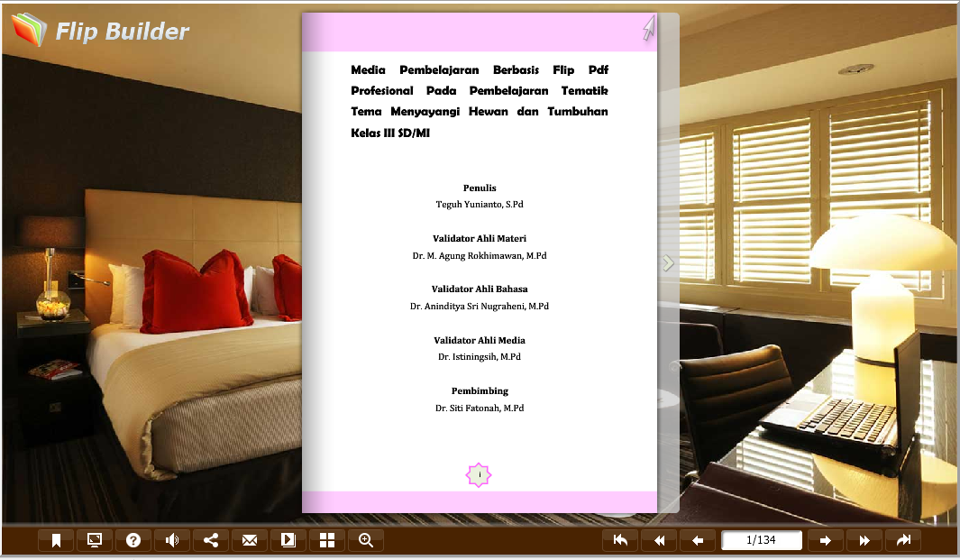

Picture 2 : Cover Design

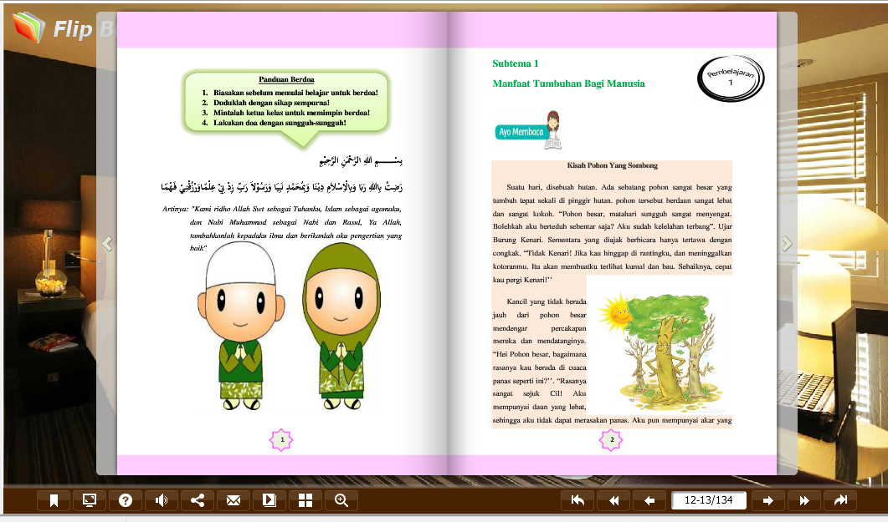

Picture 3 : Material Design

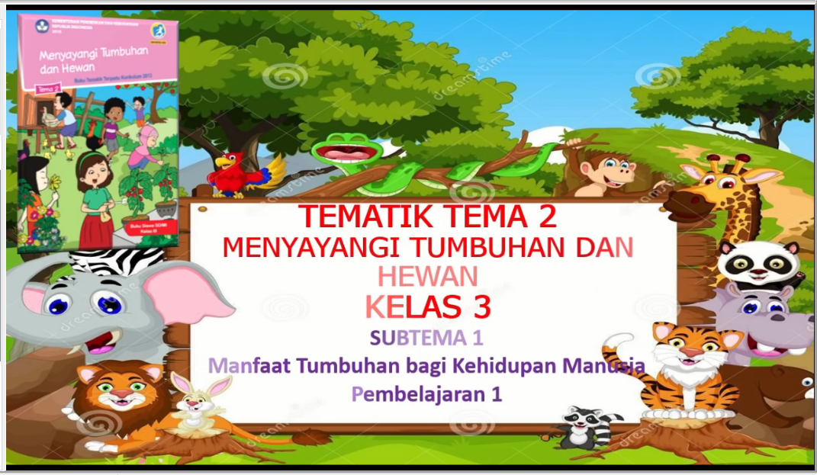

Picture 4 : Video Design

4. Design Validity

Validity is intended as a consideration for media experts, material experts and linguists. Based on the weaknesses of the product, it is expected to make a better and feasible media to be used. The results of the media expert's validity can be seen in figure 1.

Figure 1 : the result of media expert validity

Based on figure 1, the display/ design aspect of the media was obtained an average of 90%, for the average of media presentation aspect was 100%, and for the media aesthetical aspect had an average of 93.33%. The overall average obtained on the media expert validation was 94.54% with the criteria "very feasible".

Figure 2 : the result of material expert validity

Based on figure 2, the curriculum aspect was obtained an average of 86.66%, the modern aspect of the material was 80% of average, the presentation technique aspect was 90% of average, and the contextual aspect was obtained 86.66% of average. The overall average obtained in the material expert validity was 86.66% with "very feasible" criteria.

Figure 3 : linguist validation result

Based on figure 3, words and language used aspect was obtained an average of 86.66%, for the suitability aspect of students’ development, the average score was 100%, and the communicative aspect was obtained an average of 96%. The overall average was obtained in the linguist validation is 94.54% with the criteria "very feasible".

5. Design revision

In this step, revision are made based on the assessment of material expert, linguist, and media expert validator towards the product that has been developed namely professional flip pdf learning media. The table of suggestion can be seen in table 5 and 6.

Table 5.

The Validity of Suggestions from Material Experts

|  |  |
| --- | --- |
| No | Suggestion/input |
| 1 | It will be better to use concept map to understand the material that have been presented |
| 2 | The material mastery is still at the LOST level not to HOST level. |

Table 6.

The Validity of Suggestions from Linguist

|  |  |
| --- | --- |
| No | Suggestion/input |
| 1 | Correct typos |
| 2 | Correct the word that indicates the place |

6. Product Trial

The trial phase was carried out to determine the response of teachers and students in MI Ma'arif Darussalam Plaosan Klaten, Central Java. The results of response from teachers and students as followed.

Figure 4. the results of the educator’s response

Based on figure 4 about the teachers' responses, the curriculum aspect was obtained an average of 95%, the modern aspect was obtained an average of 96%, the aspect of media accuracy was obtained an average of 92.5%, in the aspect of implementation was obtained the average of 96.66%. With the overall average score obtained for teachers practitioners was 95% with “very feasible” criteria.

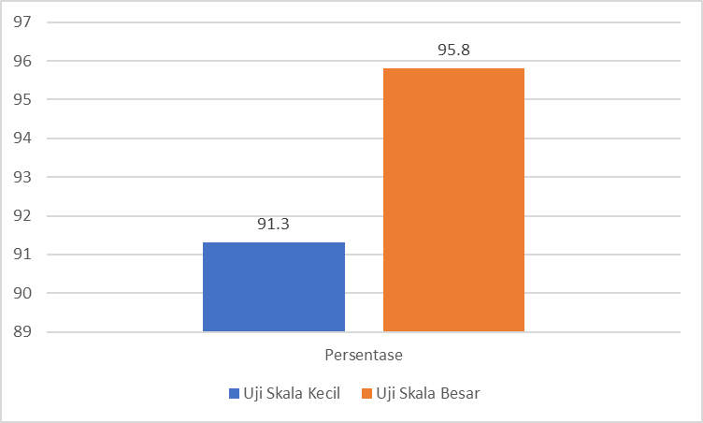

Figure 5. the results of student responses

Small group trials were obtained an average of 91.3% with the criteria of very interesting interpretation, and the results of large-scale trials were obtained an average of 95.8% with the criteria very interesting interpretation.

7. Product Revise

In this step, it is not necessary to be revised because based on the small-scale and large-scale product trials, professional flip pdf learning media was very interesting and very feasible to use as a media that could help the thematic learning process with the loving plants and animals theme.

**CONCLUSION**

Based on the data analysis, it can be concluded that the development of learning media professional flip pdf with the percentage 94.54% from media experts with the category very feasible, material experts 86.66% with very feasible category, linguist 94.54% with a very feasible category. In addition, the teacher's response is obtained the average of 95% with the very feasible category, small-scale trials is obtained an average of 91.3% with very attractive interpretation criteria and large-scale trials is obtained 95.8% with very attractive interpretation criteria.

Professional flip pdf based learning media that has been developed was very feasible and very interesting as a thematic learning media. But it needs to be expanded so that it can be used to all grade levels in elementary school with the different material.

**REFERENCES**

Agustin, Ririn Dwi, And Shandi Pratama. 2020. ‘E-Modul Dengan Pendekatan Saintifik Menggunakan Flip Pdf Profesional Pada Materi Persegi Dan Persegi Panjang’. Prosiding Seminar Nasional Ikip Budi Utomo 1 (01): 472–78.

Arda, Arda, Sahrul Saehana, And Darsikin Darsikin. 2015. ‘Pengembangan Media Pembelajaran Interaktif Berbasis Komputer Untuk Siswa Smp Kelas Viii’. Mitra Sains 3 (1): 69–77.

Arsyad, Ashar. 2016. Media Pembelajaran. Jakarta: Pt Raja Grafindo Persada.

Chairul, Anwar. Diva Press. Teori-Teori Pendidikan Klasik Hingga Kontemporer. Yogyakarat: 2017.

Hidayah, Nurul. 2015. ‘Pembelajaran Tematik Integratif Di Sekolah Dasar’. Terampil: Jurnal Pendidikan Dan Pembelajaran Dasar 2 (1): 34–49.

Latifah, Sri. 2016. ‘Pengembangan Lembar Kerja Peserta Didik (Lkpd) Berorientasi Nilai-Nilai Agama Islam Melalui Pendekatan Inkuiri Terbimbing Pada Materi Suhu Dan Kalor’. Jurnal Ilmiah Pendidikan Fisika Al-Biruni 5 (1): 43–51..

Narti, Yuni, Punaji Setyosari, I Nyoman Sudana Degeng, And Wasis D Dwiyogo. 2015. ‘Thematic Learning Implementation In Elementary School (Phenomenology Studies In Pamotan Sdn 01 And 01 Majangtengah Dampit Malang)’ 5 (11): 7.

Putra, Nusa. 2015. Research & Development. Jakarta: Pt Raja Grafindo Persada.

Ramli, M. 2015. ‘Media Pembelajaran Dalam Perspektif Al-Qur’an Dan Al-Hadits’ 13: 25.

Rufiana, Intan Sari. 2016. ‘Level Kognitif Soal Pada Buku Teks Matematika Kurikulum 2013 Kelas Vii Untuk Pendidikan Menengah’, 10.

Setiawan, Ari, Syarief Fajaruddin, And Dinar Westri Andini. 2019. ‘Development An Honesty And Discipline Assessment Instrument In The Integrated Thematic Learning At Elementary School’. Jurnal Prima Edukasia 7 (1): 9–19.

Sholichah, Aas Siti. 2018. ‘Teori-Teori Pendidikan Dalam Al-Qur’an’. Edukasi Islami: Jurnal Pendidikan Islam 7 (01): 23–46.

Sugiyono, Sugiyono. 2017. Metode Penelitian Pendidikan Pendekatan, Kuantitatif, Kualitatif Dan R & D. Bandung: Alfabeta.

Suyatmini, Suyatmini. 2017. ‘Implementasi Kurikulum 2013 Pada Pelaksanaan Pembelajaran Akuntansi Di Sekolah Menengah Kejuruan’. Jurnal Pendidikan Ilmu Sosial 27 (1): 60–68.

Utami, Resti. 2017. ‘Pengembangan E-Lks Berbasis Metakognisi Menggunakan 3d Page Flip Pada Materi Larutan Elektrolit Dan Non-Elektrolit Di Kelas X Mipa Sma Negeri 1 Muaro Jambi’. Jurnal Pendidikan Kimia, October.

W Creswell, Jhon. 2019. Research Design. Yogyakarat: Pustaka Pelajar.

Watin, E. 2017. ‘Efektivitas Penggunaan E-Book Dengan Flip Pdf Professional Untuk Melatihkan Keterampilan Proses Sains’, 6.

Widyastono, Herry. 2014. Pengembangan Kurikulum Di Era Otonomi Daerah Dari Kurikulum 2004, 2006 Ke Kurikulum 2013. Jakarta.

Yuliati Zakiyah, Qiqi. 2014. Pendidikan Nilai Kajian Teori Dan Praktiknya Di Sekolah. Bandung: Pustaka Setia.

Yunianto, Teguh. 2021. ‘Pengembangan Rps-Flip Builder Untuk Meningkatkan Pemahaman Ipa Dalam Pembelajaran Di Masa Covid-19’. Jurnal Fundadikdas (Fundamental Pendidikan Dasar) 4 (1): 1–8.

Yunianto, Teguh, Hasan Sastra Negara, And Suherman Suherman. 2019. ‘Flip Builder : Pengembangannya Pada Media Pembelajaran Matematika’. Terampil: Jurnal Pendidikan Dan Pembelajaran Dasar 6 (2): 115–27.