**LAMPIRAN**

**HASIL ANALISIS KONSENTRASI PB DALAM EKSTRAK DARI LABORATORIUM TERPADU UNIVERSITAS ISLAM INDONESIA (UII)**

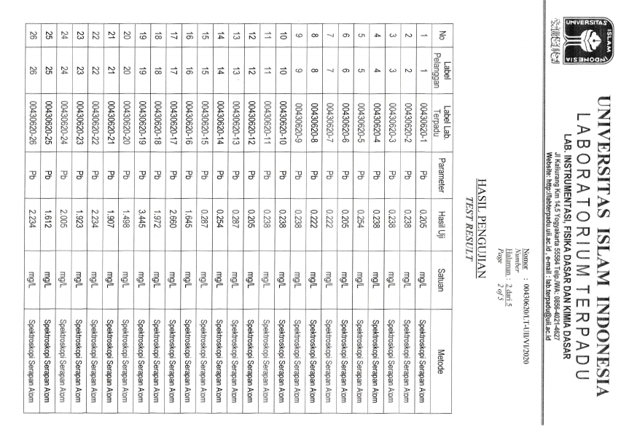

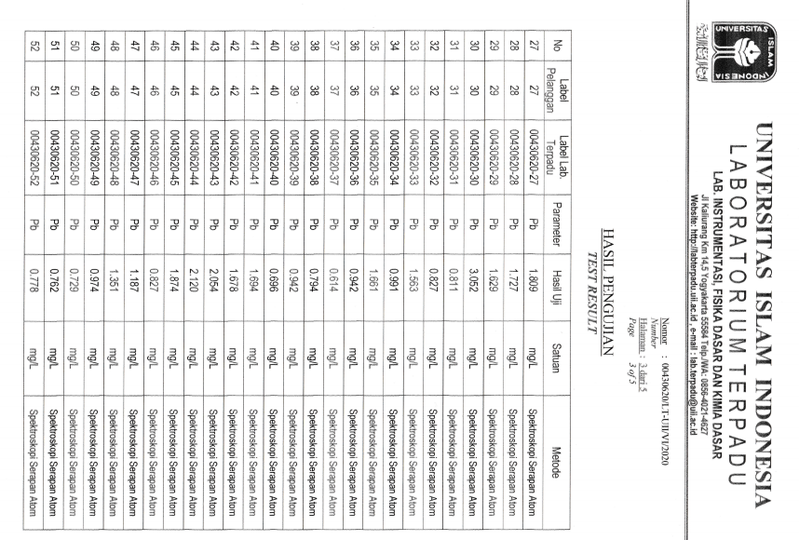

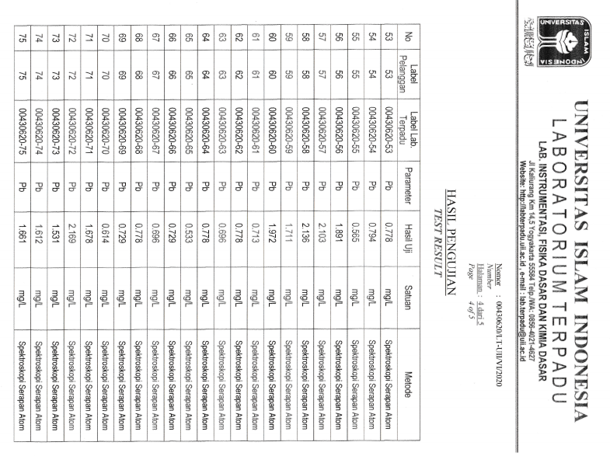

**DATA LAPANGAN**

Parameter Fisik-Kimia Sungai Gajah Wong Yogyakarta

|  |  |  |  |  |
| --- | --- | --- | --- | --- |
| Stasiun | Suhu (oC) | pH | Oksigen Terlarut  (ppm) | Kecepatan Arus  (m/s) |
| Stasiun 1  (GW Hulu) | 27 | 6,75 | 1,25 | 0,18 |
| Stasiun 2  (GW Tengah) | 27 | 6,62 | 0,91 | 0,38 |
| Stasiun 3  (GW Hilir) | 27 | 6,8 | 1,08 | 0,14 |

Sedimen Sungai Gajah Wong

|  |  |  |  |  |  |
| --- | --- | --- | --- | --- | --- |
| Stasiun | Sedimen | Berat Basah (BB) | Berat Kering (BK) | Kadar Air (KA)  (%) | Bentuk Sedimen |
| Gram (gr) | |
| Stasiun 1  (GW Hulu) | S1 | 30,004 | 18,101 | 39,67 | Pasir dan lumpur |
| S2 | 30,010 | 10,289 | 65,71 | Lumpur |
| S3 | 30,023 | 14,913 | 50,32 | Lumpur |
| S4 | 30,014 | 6,822 | 77,27 | Lumpur |
| S5 | 30,073 | 16,572 | 44,89 | Lumpur |
| Stasiun 2  (GW Tengah) | S1 | 30,012 | 21,921 | 26,95 | Pasir |
| S2 | 30,044 | 22,743 | 24,30 | Pasir |
| S3 | 30,083 | 21,608 | 28,17 | Pasir |
| S4 | 30,092 | 21,121 | 29,81 | Pasir |
| S5 | 30,067 | 21,631 | 28,05 | Pasir |
| Stasiun 3  (GW Hilir) | S1 | 30,041 | 17,811 | 40,71 | Pasir dan lumpur |
| S2 | 30,053 | 21.151 | 29,62 | Pasir dan lumpur |
| S3 | 30,044 | 21,012 | 30,06 | Pasir dan lumpur |
| S4 | 30,095 | 21,643 | 28,08 | Pasir dan lumpur |
| S5 | 30,085 | 20,333 | 32,41 | Pasir dan lumpur |

Hasil Pengujian Kadar Logam Berat Timbal (Pb) pada media lingkungan (air dan sedimen)

|  |  |  |  |  |  |  |  |  |  |  |
| --- | --- | --- | --- | --- | --- | --- | --- | --- | --- | --- |
| Stasiun | Kadar Pb (mg/L) | | | | | | | | | |
| Air | | | | | Sedimen | | | | |
| S1 | S2 | S3 | S4 | S5 | S1 | S2 | S3 | S4 | S5 |
| Stasiun 1  (GW Hulu) | 0,205 | 0,238 | 0,238 | 0,238 | 0,254 | 1,645 | 2,660 | 1,972 | 3,445 | 1,498 |
| Stasiun 2  (GW Tengah) | 0,205 | 0,222 | 0,222 | 0,238 | 0,238 | 1,907 | 2,234 | 1,923 | 2,005 | 1,612 |
| Stasiun 3  (GW Hilir) | 0,238 | 0,205 | 0,287 | 0,254 | 0,287 | 2,234 | 1,809 | 1,727 | 1,629 | 3,052 |

Kadar Pb pada Ikan Nila (*Oreochromis niloticus*)

|  |  |  |  |  |  |
| --- | --- | --- | --- | --- | --- |
| Stasiun | Sampel ikan Nila | Berat Kering Sampel Ekstraksi  (gr) | Kadar Pb (mg/L) | | |
| Daging | Tulang | Viscera |
| Stasiun 1  (GW Hulu) | S1 | 2 | 0,942 | 1,694 | 0,811 |
| S2 | 2 | 0,614 | 1,678 | 0,827 |
| S3 | 2 | 0,794 | 2,054 | 1,563 |
| S4 | 2 | 0,942 | 2,120 | 0,991 |
| S5 | 2 | 0,696 | 1,874 | 1,661 |
| Stasiun 2  (GW Tengah) | S1 | 2 | 0,762 | 1,891 | 0,827 |
| S2 | 2 | 0,778 | 2,103 | 1,187 |
| S3 | 2 | 0,778 | 2,136 | 1,351 |
| S4 | 2 | 0,794 | 1,711 | 0,974 |
| S5 | 2 | 0,565 | 1,972 | 0,729 |
| Stasiun 3  (GW Hilir) | S1 | 2 | 0,729 | 1,678 | 0,713 |
| S2 | 2 | 0,696 | 2,169 | 0,778 |
| S3 | 2 | 0,778 | 1,531 | 0,696 |
| S4 | 2 | 0,729 | 1,612 | 0,778 |
| S5 | 2 | 0,614 | 1,661 | 0,553 |

**1.3. Sampel Ikan Nila (*Oreochromis niloticus*) yang diperoleh dari Sungai Gajah Wong**

|  |  |  |  |  |  |  |  |  |  |  |  |  |
| --- | --- | --- | --- | --- | --- | --- | --- | --- | --- | --- | --- | --- |
| **Stasiun** | **Sampel ikan Nila** | **Berat Utuh (gr)** | **Panjang (cm)** | **Daging** | | | **Tulang** | | | **Viscera** | | |
| BB | BK | KA (%) | BB | BK | KA (%) | BB | BK | KA (%) |
| Stasiun 1  (GW Hulu) | S1 | 91,9 | 17 | 31,4 | 6,4 | 79,61 | 15,2 | 4,2 | 72,36 | 11,4 | 3,1 | 72,80 |
| S2 | 213,1 | 23 | 62,7 | 15,5 | 75,27 | 29,2 | 7,6 | 73,97 | 21,5 | 5,8 | 73,02 |
| S3 | 192,2 | 21 | 69,5 | 17 | 75,53 | 20,4 | 6,5 | 68,13 | 22,9 | 6 | 73,79 |
| S4 | 147,6 | 21,5 | 44,5 | 9,5 | 78,65 | 19,1 | 5,7 | 70,15 | 13,7 | 2,6 | 81,02 |
| S5 | 226,7 | 23,5 | 73,3 | 23,1 | 68,48 | 25,8 | 6,3 | 75,58 | 21,5 | 4 | 81,39 |
| Stasiun 2  (GW Tengah) | S1 | 159.8 | 21 | 48,2 | 12,2 | 74,68 | 24,3 | 7,2 | 70,37 | 18 | 4,6 | 74,44 |
| S2 | 192,3 | 21 | 39,3 | 8,6 | 78,11 | 25,9 | 6,2 | 76,06 | 15,7 | 3,2 | 79,61 |
| S3 | 171,6 | 22 | 51,7 | 12,7 | 75,43 | 35,9 | 12,1 | 66,29 | 10,3 | 2,1 | 79,61 |
| S4 | 108,9 | 18,5 | 32,4 | 6,7 | 79,32 | 27,6 | 7 | 74,63 | 14 | 3,4 | 75,71 |
| S5 | 231,1 | 24 | 76,4 | 19,2 | 74,86 | 43,6 | 13,8 | 68,34 | 21,6 | 6,2 | 71,29 |
| Stasiun 3  (GW Hilir) | S1 | 173,1 | 20 | 65,8 | 17,6 | 73,25 | 33,5 | 10,7 | 68,05 | 7,6 | 2 | 73,68 |
| S2 | 200,2 | 21,5 | 74 | 21,7 | 70,67 | 31,4 | 10,2 | 67,51 | 19,7 | 4,5 | 77,15 |
| S3 | 192,9 | 21 | 66,7 | 18,7 | 71,96 | 43,3 | 16 | 63,04 | 19,4 | 4,5 | 76,80 |
| S4 | 146,5 | 20 | 51,3 | 13 | 74,65 | 40 | 12,2 | 69,5 | 13,4 | 2,7 | 79,85 |
| S5 | 216,3 | 21 | 76,5 | 24,8 | 67,58 | 33 | 9,2 | 78,54 | 23,6 | 6,6 | 72,03 |

**ANALISIS STATISTIK**

|  |  |  |  |  |  |  |  |  |
| --- | --- | --- | --- | --- | --- | --- | --- | --- |
| **Descriptives** | | | | | | | | |
| Konsentrasi Pb | | | | | | | | |
|  | N | Mean | Std. Deviation | Std. Error | 95% Confidence Interval for Mean | | Minimum | Maximum |
| Lower Bound | Upper Bound |
| Stasiun 1 | 5 | .23460 | .017939 | .008022 | .21233 | .25687 | .205 | .254 |
| Stasiun 2 | 5 | .22500 | .013748 | .006148 | .20793 | .24207 | .205 | .238 |
| Stasiun 3 | 5 | .25420 | .034766 | .015548 | .21103 | .29737 | .205 | .287 |
| Total | 15 | .23793 | .025485 | .006580 | .22382 | .25205 | .205 | .287 |

**Konsentrasi Pb pada Media Air**

**Homogeneous Subsets**

|  |  |  |
| --- | --- | --- |
| **Konsentrasi Pb** | | |
| Tukey HSDa | | |
| Konsentrasi Pb pada Air | N | Subset for alpha = 0.05 |
| 1 |
| Stasiun 2 | 5 | .22500 |
| Stasiun 1 | 5 | .23460 |
| Stasiun 3 | 5 | .25420 |
| Sig. |  | .173 |
| Means for groups in homogeneous subsets are displayed. | | |
| a. Uses Harmonic Mean Sample Size = 5,000. | | |

**Konsentrasi Pb pada Media Sedimen**

|  |  |  |  |  |  |  |  |  |
| --- | --- | --- | --- | --- | --- | --- | --- | --- |
| **Descriptives** | | | | | | | | |
| Konsentrasi Pb | | | | | | | | |
|  | N | Mean | Std. Deviation | Std. Error | 95% Confidence Interval for Mean | | Minimum | Maximum |
| Lower Bound | Upper Bound |
| Stasiun 1 | 5 | 2.24400 | .806963 | .360885 | 1.24202 | 3.24598 | 1.498 | 3.445 |
| Stasiun 2 | 5 | 1.93620 | .223356 | .099888 | 1.65887 | 2.21353 | 1.612 | 2.234 |

|  |  |  |  |  |  |  |  |  |
| --- | --- | --- | --- | --- | --- | --- | --- | --- |
| Stasiun 3 | 5 | 2.09020 | .585113 | .261671 | 1.36369 | 2.81671 | 1.629 | 3.052 |
| Total | 15 | 2.09013 | .561286 | .144923 | 1.77930 | 2.40096 | 1.498 | 3.445 |

**Homogeneous Subsets**

|  |  |  |
| --- | --- | --- |
| **Konsentrasi Pb** | | |
| Tukey HSDa | | |
| Konsentrasi Pb pada Sedimen | N | Subset for alpha = 0.05 |
| 1 |
| Stasiun 2 | 5 | 1.93620 |
| Stasiun 3 | 5 | 2.09020 |
| Stasiun 1 | 5 | 2.24400 |
| Sig. |  | .695 |
| Means for groups in homogeneous subsets are displayed. | | |
| a. Uses Harmonic Mean Sample Size = 5,000. | | |

**Konsentrasi Pb pada bagian tubuh Ikan Nila**

|  |  |  |  |  |  |  |  |  |  |
| --- | --- | --- | --- | --- | --- | --- | --- | --- | --- |
| **Descriptives** | | | | | | | | | |
|  | | N | Mean | Std. Deviation | Std. Error | 95% Confidence Interval for Mean | | Minimum | Maximum |
| Lower Bound | Upper Bound |
| Daging Ikan Nila | Titik 1 | 5 | .797600 | .1464131 | .0654779 | .615804 | .979396 | .6140 | .9420 |
| Titik 2 | 5 | .735400 | .0959260 | .0428994 | .616292 | .854508 | .5650 | .7940 |
| Titik 3 | 5 | .709200 | .0607347 | .0271614 | .633788 | .784612 | .6140 | .7780 |
| Total | 15 | .747400 | .1062092 | .0274231 | .688583 | .806217 | .5650 | .9420 |
| Tulang Ikan Nila | Titik 1 | 5 | 1.884000 | .2020099 | .0903416 | 1.633172 | 2.134828 | 1.6780 | 2.1200 |
| Titik 2 | 5 | 1.962600 | .1719718 | .0769081 | 1.749069 | 2.176131 | 1.7110 | 2.1360 |
| Titik 3 | 5 | 1.730200 | .2518486 | .1126301 | 1.417489 | 2.042911 | 1.5310 | 2.1690 |
| Total | 15 | 1.858933 | .2195738 | .0566937 | 1.737337 | 1.980529 | 1.5310 | 2.1690 |

Viscera Ikan Nila

|  |  |  |  |  |  |  |  |  |  |
| --- | --- | --- | --- | --- | --- | --- | --- | --- | --- |
|  | Titik 1 | 5 | 1.170600 | .4105177 | .1835891 | .660875 | 1.680325 | .8110 | 1.6610 |
|  | Titik 2 | 5 | 1.013600 | .2555833 | .1143003 | .696251 | 1.330949 | .7290 | 1.3510 |
| Titik 3 | 5 | .703600 | .0920560 | .0411687 | .589297 | .817903 | .5530 | .7780 |
| Total | 15 | .962600 | .3310177 | .0854684 | .779289 | 1.145911 | .5530 | 1.6610 |

**Homogeneous Subsets**

|  |  |  |
| --- | --- | --- |
| **Daging Ikan Nila** | | |
| Duncana | | |
| Titik | N | Subset for alpha = 0.05 |
| 1 |
| Titik 3 | 5 | .709200 |
| Titik 2 | 5 | .735400 |
| Titik 1 | 5 | .797600 |
| Sig. |  | .237 |
| Means for groups in homogeneous subsets are displayed. | | |
| a. Uses Harmonic Mean Sample Size = 5,000. | | |

|  |  |  |
| --- | --- | --- |
| **Tulang Ikan Nila** | | |
| Duncana | | |
| Titik | N | Subset for alpha = 0.05 |
| 1 |
| Titik 3 | 5 | 1.730200 |
| Titik 1 | 5 | 1.884000 |
| Titik 2 | 5 | 1.962600 |
| Sig. |  | .123 |
| Means for groups in homogeneous subsets are displayed. | | |
| a. Uses Harmonic Mean Sample Size = 5,000. | | |

|  |  |  |  |
| --- | --- | --- | --- |
| **Viscera Ikan Nila** | | | |
| Duncana | | | |
| Titik | N | Subset for alpha = 0.05 | |
| 1 | 2 |
| Titik 3 | 5 | .703600 |  |
| Titik 2 | 5 | 1.013600 | 1.013600 |
| Titik 1 | 5 |  | 1.170600 |
| Sig. |  | .110 | .400 |
| Means for groups in homogeneous subsets are displayed. | | | |
| a. Uses Harmonic Mean Sample Size = 5,000. | | | |